Working with Maven, Spring, Spring Boot

Student Workbook
Version 1.1
Table of Contents
Module 1 Maven 1-1
Section 1–1 Maven 1-2
The Case for Maven 1-3
The Case for Maven cont'd 1-4
Maven 1-5
Installation of Maven 1-6
Setting up your Environment Variables 1-7
Setting up your Environment Variables cont'd 1-8
Section 1–2 Creating a Project with Maven 1-9
Creating a Maven Project 1-10
Selecting the Archetype 1-11
Creating the Archetype 1-12
Creating the Archetype cont'd 1-13
Creating the Archetype cont'd 1-14
Maven Project Structure 1-15
What Just Happened? 1-16
Understanding pom.xml 1-17
Configure .gitignore 1-18
Exercises 1-19
Section 1–3 Importing a Maven Project into Eclipse 1-20
Importing a Maven Project 1-21
Importing a Maven Project cont'd 1-22
Understanding the Layout 1-23
Still Need to Fix JRE Problems 1-24
Running in Eclipse 1-25
Adding A Run Configuration in Eclipse for Maven 1-26
Creating a Run Configuration for Maven 1-27
Creating a Run Configuration for Maven cont'd 1-28
Viewing the Run 1-29
Exercises 1-30
Section 1–4 Adding to the Maven pom.xml 1-31
The pom.xml file in Eclipse 1-32
When to add dependencies 1-33
How to add dependencies 1-34
How to add dependencies cont'd 1-35
Exercises 1-36
Module 2 Spring Framework 2-1
Section 2–1 Spring Framework 2-2
Spring Framework 2-3
Dependency Injection (DI) and Inversion of Control (IoC) 2-4
Spring and DI / IoC 2-5
Styles of Dependency Injection 2-7
Section 2–2 Example: Simple Spring App 2-9
Getting Started with a Basic Spring Application 2-10
Getting Started with a Basic Spring Application cont'd 2-11
Ensuring Dependencies are Loaded into Eclipse 2-12
Java Beans 2-13
Spring Beans 2-14
Adding a beans.xml Configuration File 2-15
Adding a beans.xml Configuration File cont'd 2-16
Example: Model for Student 2-17
Example: Model for Student cont'd 2-18
Example: Creating a RegistrationDAO 2-19
Example: Implementing RegistrationDAO cont'd 2-20
Example: Implementing RegistrationDAO cont'd 2-21
Example: Creating a Registration Service 2-22
Example: Creating a Registration Service cont'd 2-23
Main Method 2-24
Main Method cont'd 2-25
Example: Exception Used in the Service 2-26
Final Project Structure 2-27
Exercises 2-28
Module 3 Spring Boot 3-1
Section 3–1 Getting started with Spring Boot 3-2
Spring Boot 3-3
Getting Started with Spring Boot 3-4
Creating an HIG Demo 3-5
Bringing the Spring Boot App into Eclipse 3-6
What do you get? 3-7
Exercises 3-8
Annotations 3-9
Section 3–2 Spring Boot: beans and dependency injection 3-10
Spring Beans and Spring Container 3-11
Inspecting the beans 3-13
Creating Spring Bean with @Component 3-14
Creating Spring Bean with @Bean 3-15
Component scanning 3-16
Exercises 3-17
Dependency injection 3-18
Different dependency injection types 3-19
Different dependency injection types cont'd 3-20
Exercises 3-21
Which bean will be injected 3-22
Exercises 3-24
Section 3–3 Spring Boot configuration 3-26
Configuring a Spring Boot application 3-27
Using properties 3-28
Using properties cont'd 3-29
Exercises 3-30
Using profiles 3-31
Using profiles cont'd 3-33
Exercises 3-34

Maven

Maven

The Case for Maven

Up until now, we have developed Java applications using:

IntelliJ

IntelliJ is a fully featured IDE that helps provides features to:

Create skeletal applications based on project type with folders, code files, and configuration files often in place

Manages dependencies for you

It has wizards that help create starter code

It contains a build tool that helps compile the application and then run it

It will even start the web server for you if you have it configured

The Case for Maven cont'd

However, a project built in IntelliJ is just that -- an IntelliJ project

If you want to move the project to Eclipse, the build configurations have to be created differently.

There is an option to Export the project to Eclipse

This makes it hard to switch IDEs when a better one comes along

Instead of tying a project to one IDE, you can use a project management tool that is IDE-independent

Maven

Maven is a project management tool that uses something called POM (project object model)

It is a build tool that is separate from the editor/IDE

It is used to:

manage a project's dependencies

manage a project's build process

manage a project's documentation

And to top it off, it's open source

That's why many teams like to use Maven for building and managing their Java-based projects

For a quick tutorial, see:
https://maven.apache.org/guides/getting-started/maven-in-five-minutes.html

Installation of Maven

You can tell if Maven is installed on your machine by running the following command
Example
mvn -v

If you are on a mac, you can first install Homebrew (a package manager for MacOS - https://brew.sh/)

Then, you can install maven via Homebrew - just run `brew install maven` - per here: https://formulae.brew.sh/formula/maven

For Windows users - If it isn't already installed on your machine, visit https://maven.apache.org/download.cgi and locate the files selection.

Download apache-maven-3.8.3-bin.zip

Ensure that you are downloading the binary version

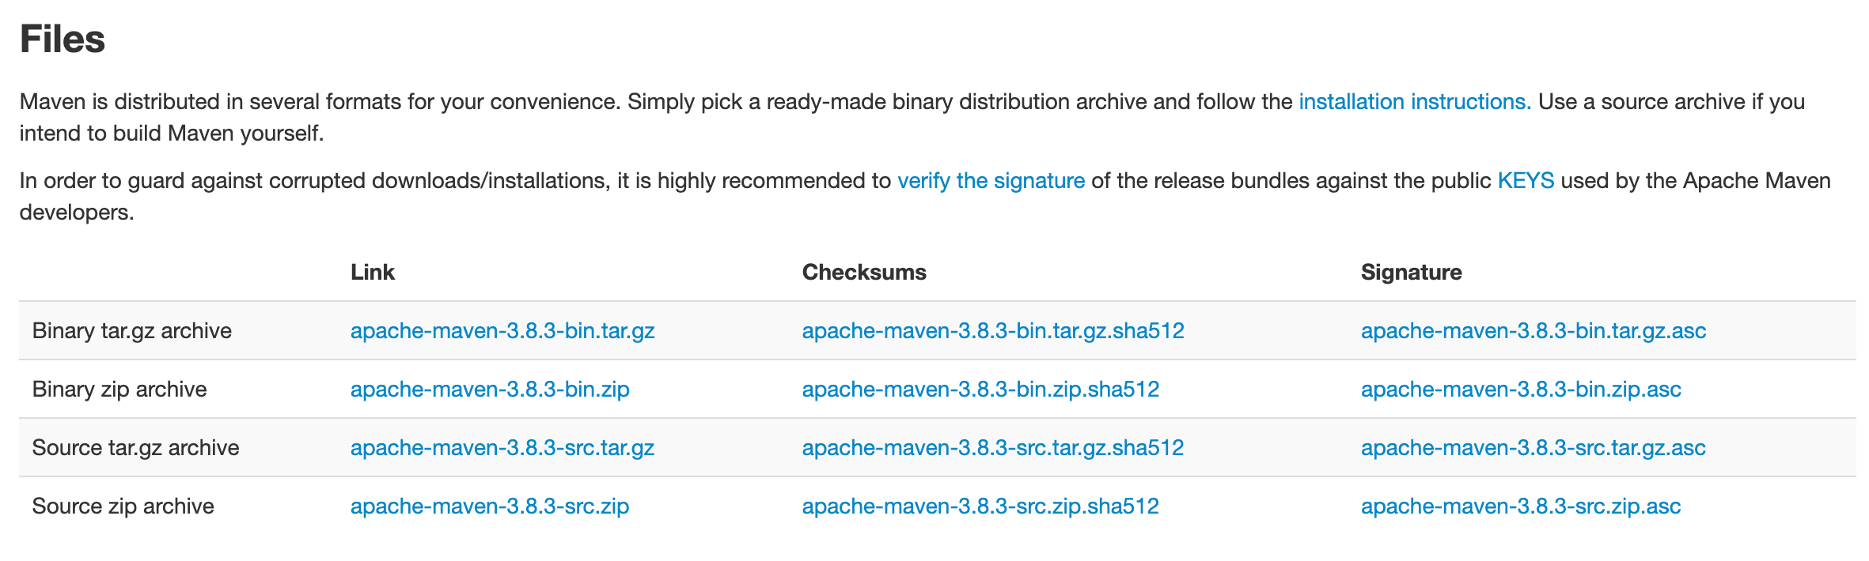

Unzip to a location that is not a project

For example: C:\Program Files\apache-maven-3.8.3

Setting up your Environment Variables

You will need to configure the environment

Create a MAVEN_HOME environment variable that points to your install location

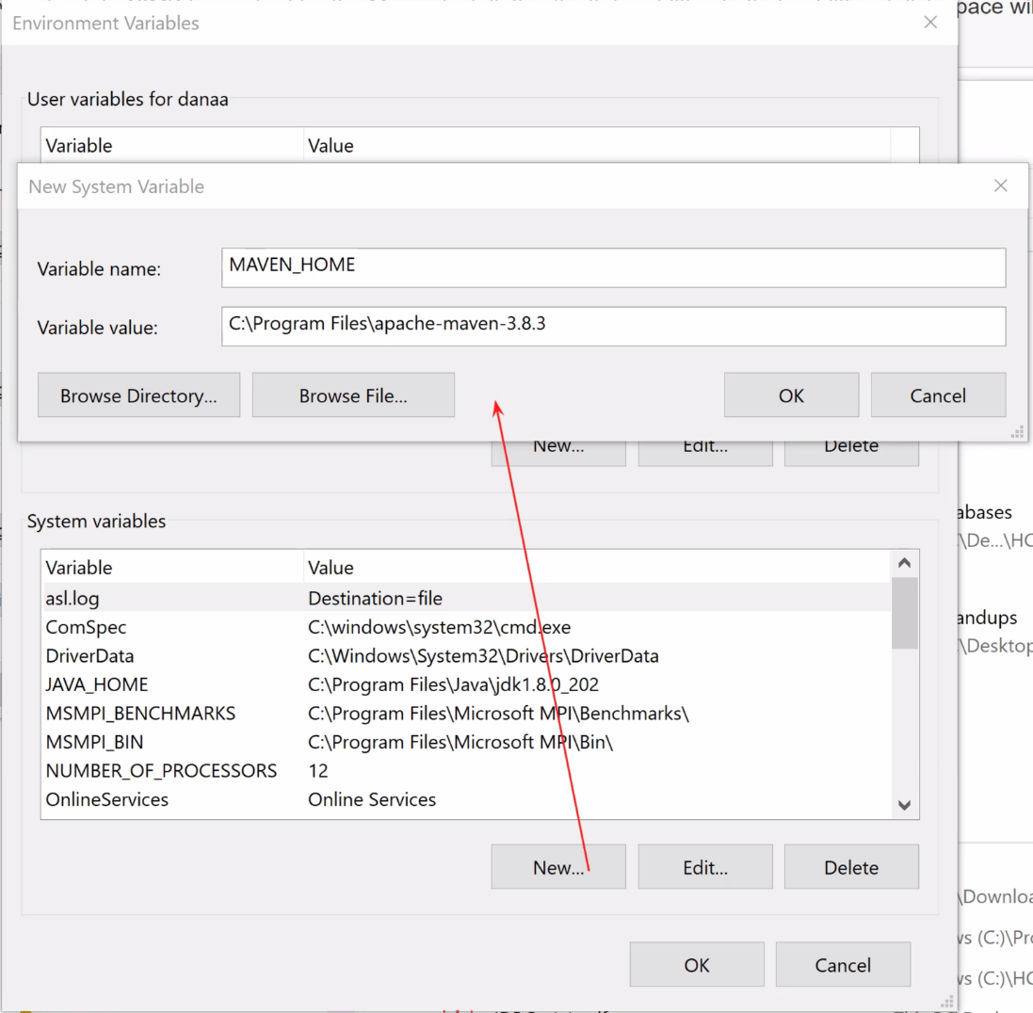

Setting up your Environment Variables cont'd

Edit the PATH environment variable and add:

%MAVEN_HOME%\bin directory

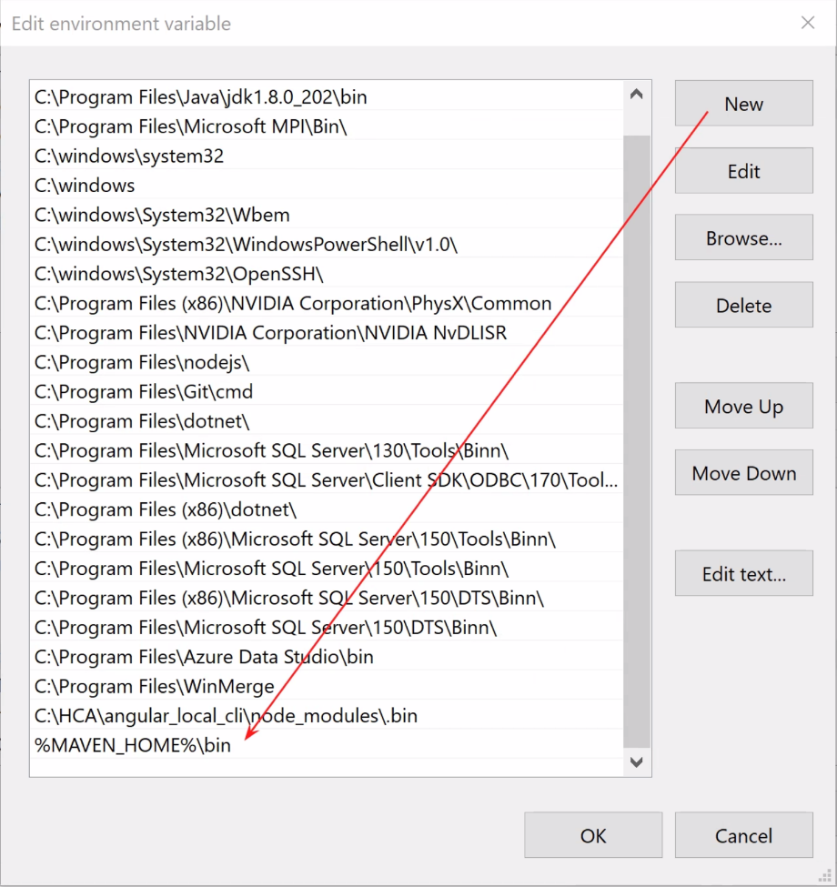

In a new terminal window, check to ensure it is installed

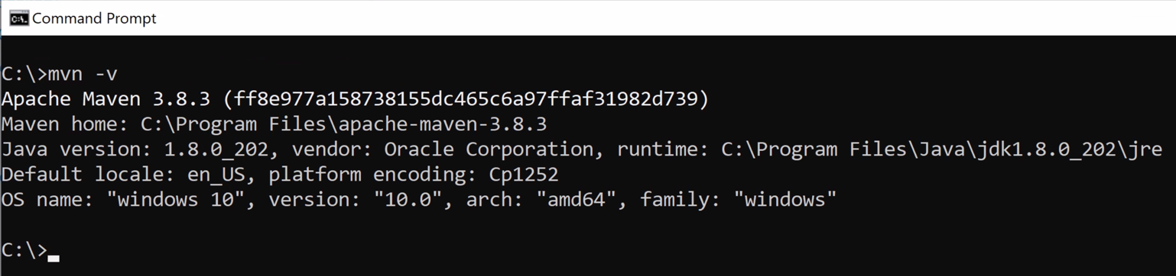

Creating a Project with Maven

Creating a Maven Project

Maven can be used to scaffold (create) starter applications

You can choose from many different types of applications

Under the hood, Maven uses the archetype plugin for this

Archetype uses the term prototypes to describe the many types of Java related projects it can build

Aside: archetype means the original pattern or model from which something is developed or made

Archetype will create the project structure and all needed starter files based on project type

To use it, bring up a terminal window in the folder that you want to contain the project

Enter the command below
Example
mvn archetype:generate

Once you type the command, lots of text will scroll by tracing what is happening under the hood

At some point, it will prompt you for what type of project you want it to create

Select number (ex: 2110) of archetype you wish to use (see next page)

Selecting the Archetype

In the following, 2110, points to the quickstart project and simple and effective project.

Scroll thru the list above the prompt to see all the hundreds of types of available projects

It will suggest 2110 (a Java application)

By hitting enter, you will select the quickstart project

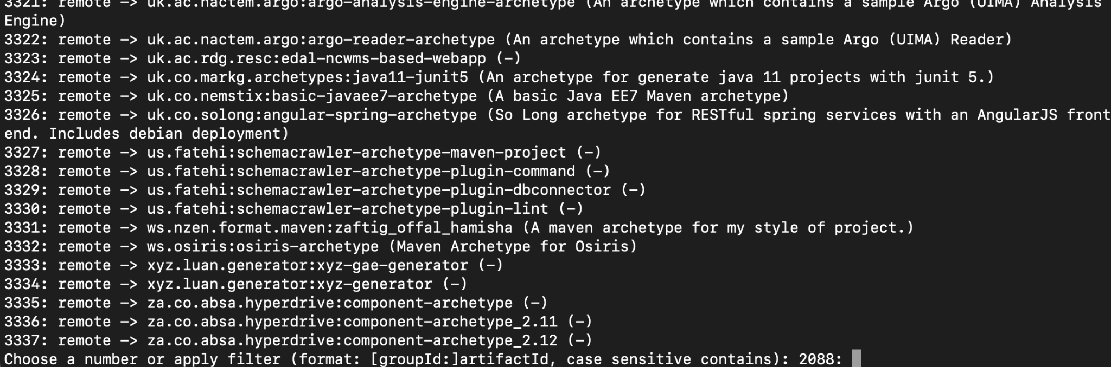

Creating the Archetype

It will suggest multiple versions of the archetype

Typically, you will select the latest (ex: 1.4)

Hit the Enter key to select

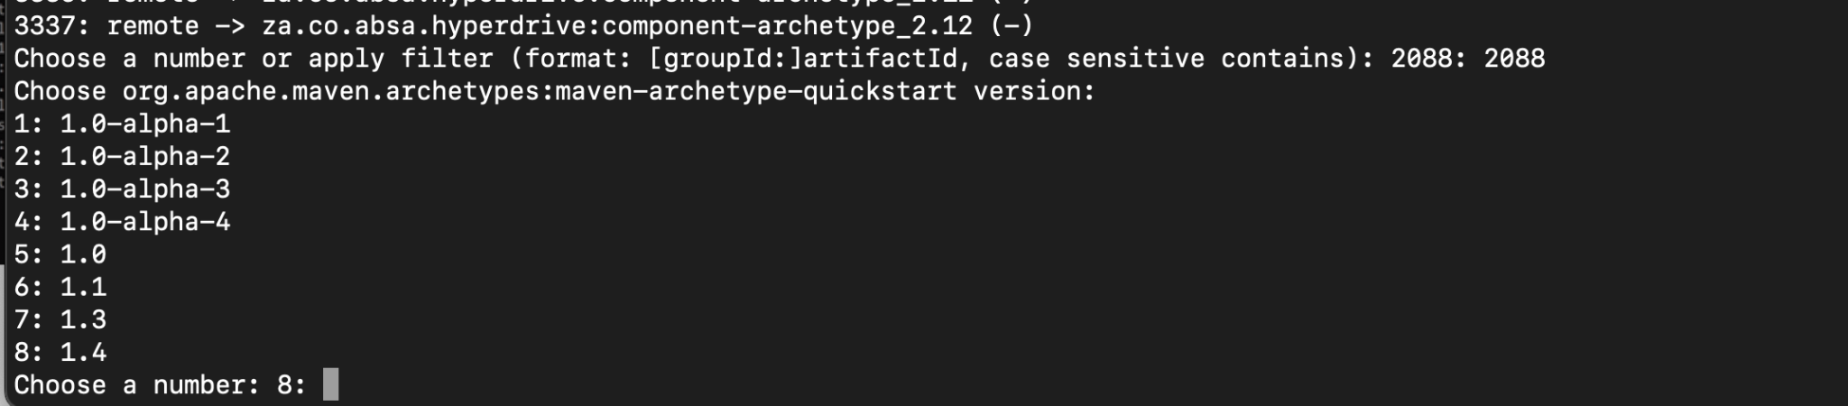

Enter a GroupID

Group ID is typically a reverse domain name - you can use com.intuit. The group ID is a unique identifier for the organization or group that created the project - for example

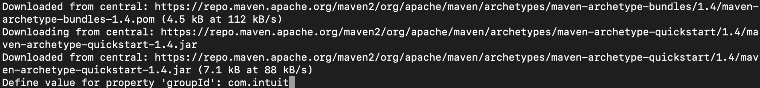

Creating the Archetype cont'd

Enter an ArtifactID

It is the name of the project - you can call it maven-demo

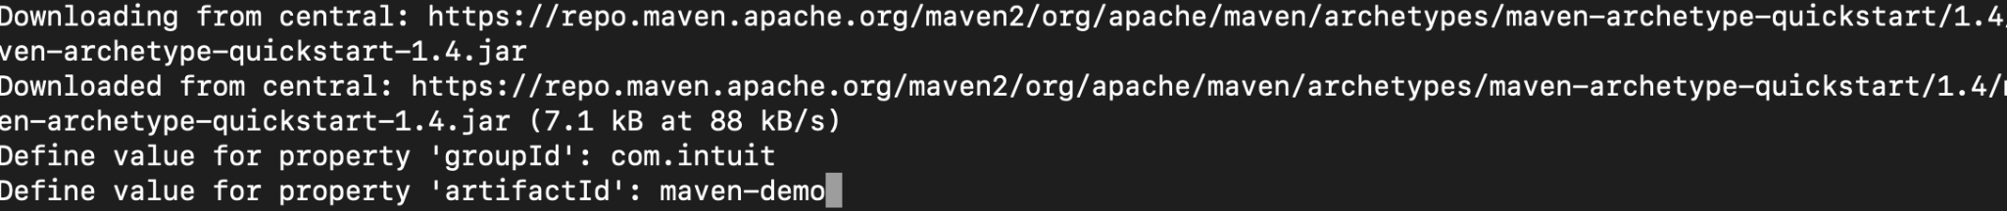

Version allows you to specify a version of the software.

If the version has a “-SNAPSHOT” suffix, it means it is currently under development

Any other value will represent that it is a release or production ready

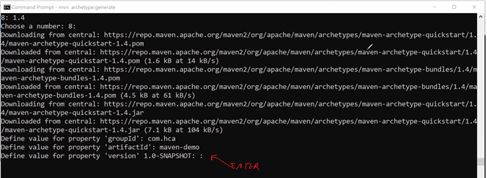

Creating the Archetype cont'd

Hit Enter on the next prompt, this will be the package in your java source code
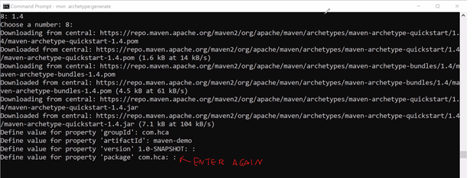

When done, this will display a “Build Success”

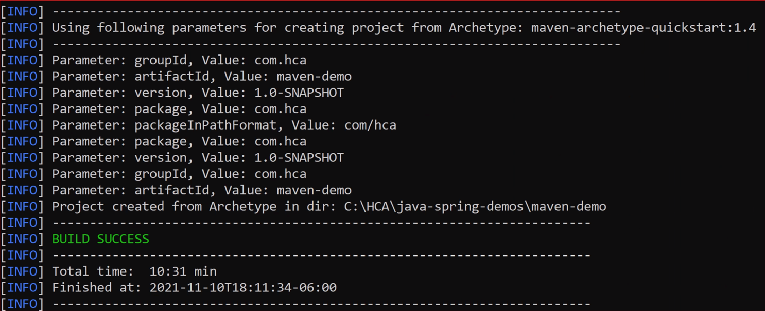

Maven Project Structure

Go ahead and cd into your new Maven directory called maven-demo. A quick look at the project reveals:

pom.xml – the build file

It will contain your build definition which include plugins and dependencies

src/main/java – location of the application code

src/test/java – location of the test code

Note that you can install the tree utility via Homebrew (just run brew install tree) - if you run tree you’ll see something like this:

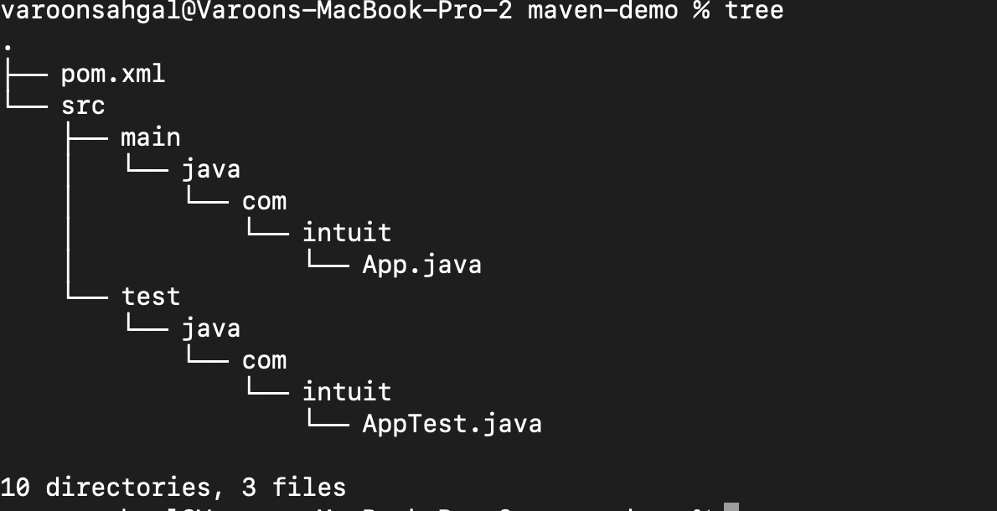

What Just Happened?

What just happened when we created the project?

Maven looked for required plugins and dependencies

Downloaded them if missing

Updated them if needed

Placed dependencies into local repository ~/.m2/repository

It also executed archetype:generate goal

Used values entered or specified on command line

Created artifactId directory

Created project files based on select artifact

Understanding pom.xml

If you examine the pom.xml file, you will find the following elements

The “coordinates” of your project: groupId, artifactId, version - commonly referred to as GAV

Properties, which can define variables used throughout the build file, and which can potentially change the behavior of the build

Dependencies – Libraries that are required for your project. Maven will manage your classpath for you.

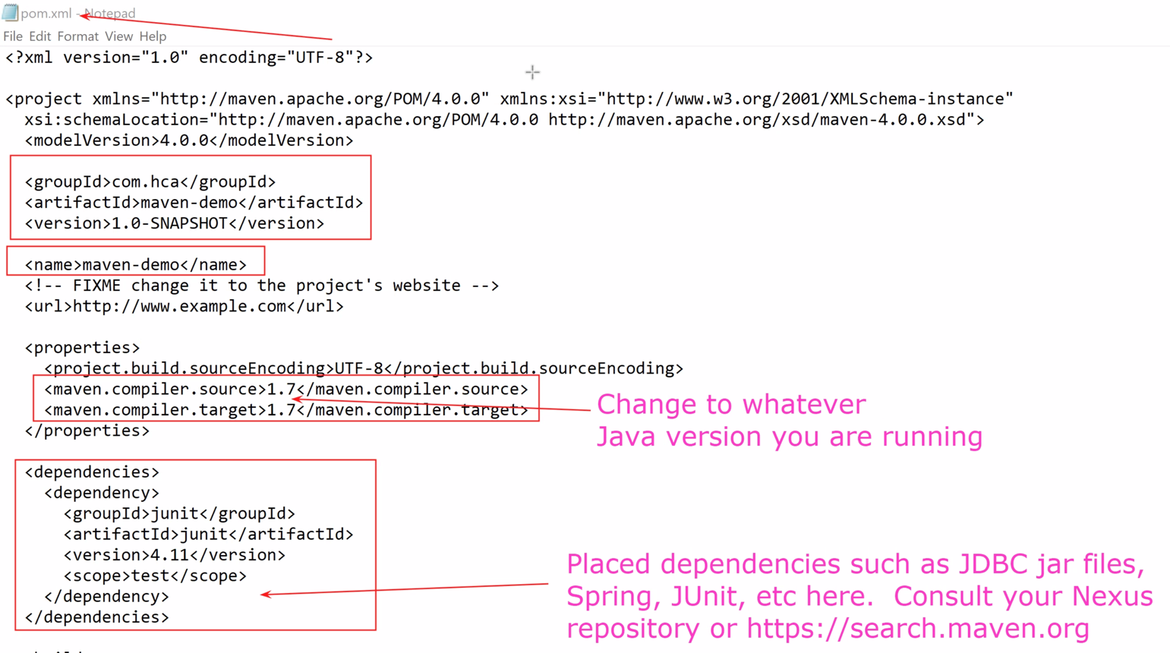

Configure .gitignore

You should configure Git to ignore the target folder

Place target in your .gitignore

The target folder contains machine-generated material

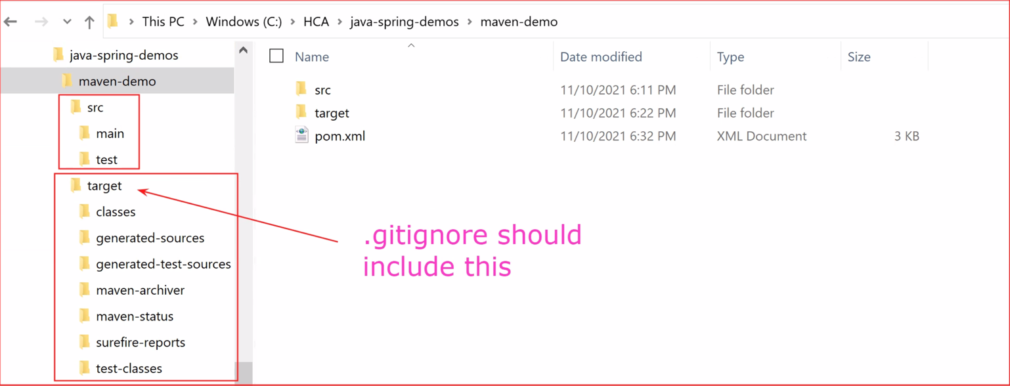

Exercises
EXERCISE 1
- We are going to generate a project using the command line using the command: mvn archetype:generate
- Select the project number for maven-archetype-quickstart.
- Choose the latest version.
- Give your project a sensible groupId, artifactId and version.
- Choose package based on your groupId.
- Add a .gitignore file to your project.
- Inspect the folder structure, it should look like the example from the workbook. If you’ve chosen a different groupId, it will have certain differences. Can you identify which ones?

Importing a Maven Project into Eclipse

Importing a Maven Project

To import into IntelliJ, you can simply open up the pom.xml

You can include an externally-created Maven project into an Eclipse workspace using File > Import…

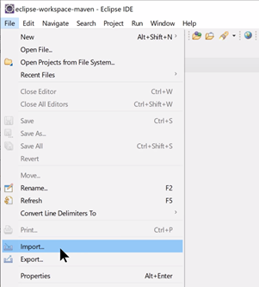

In the Import Dialog Box, Select Maven > Existing Maven Projects

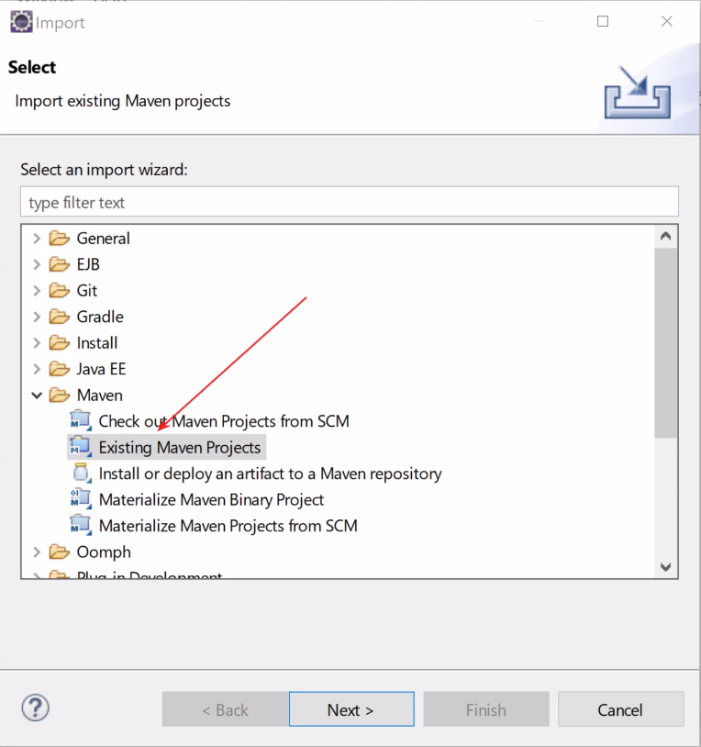

Importing a Maven Project cont'd

Locate the root Maven project folder

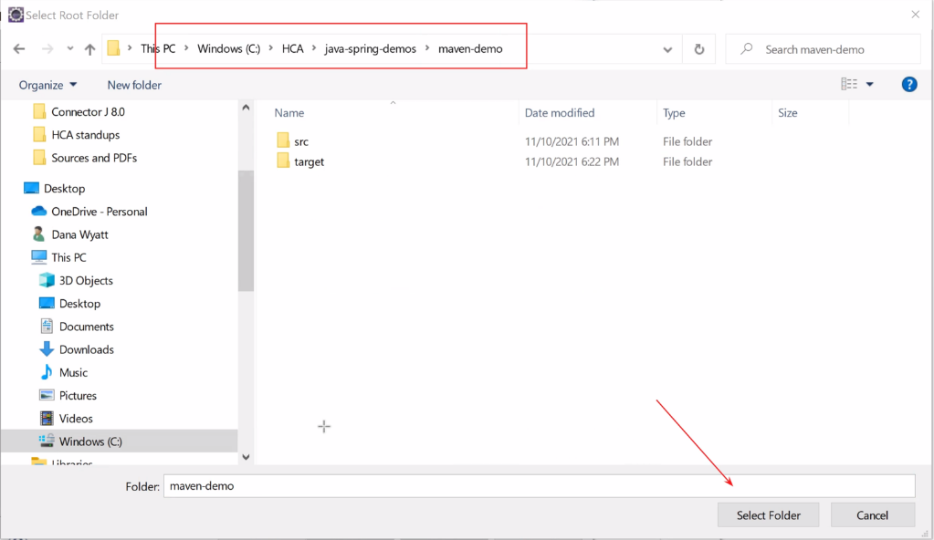

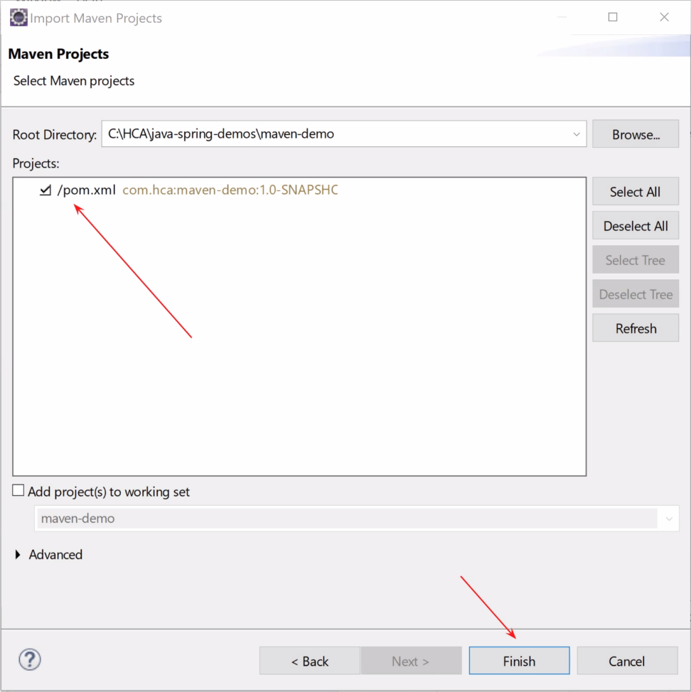

Understanding the Layout

You will see src/main/java and src/test/java

In src/main/java you will find an App.java which is very simple application "Hello World" with a main method

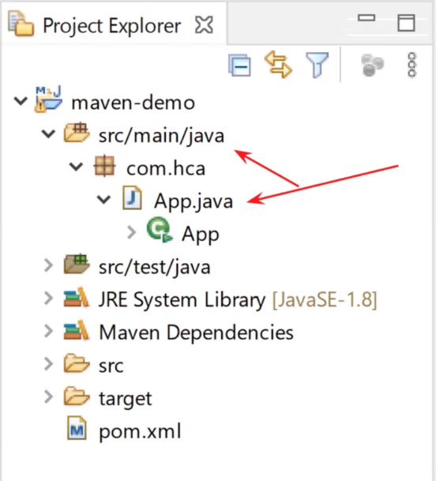

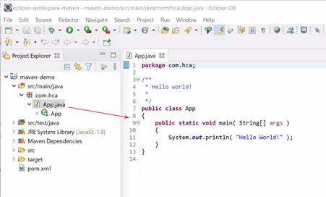

Still Need to Fix JRE Problems

Although bringing an application happens cleanly, you will need to ensure that the Java Runtime Environment is set up correctly

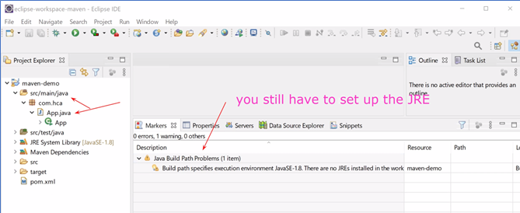

Running in Eclipse

As always, you can run in Eclipse by running the green arrow button

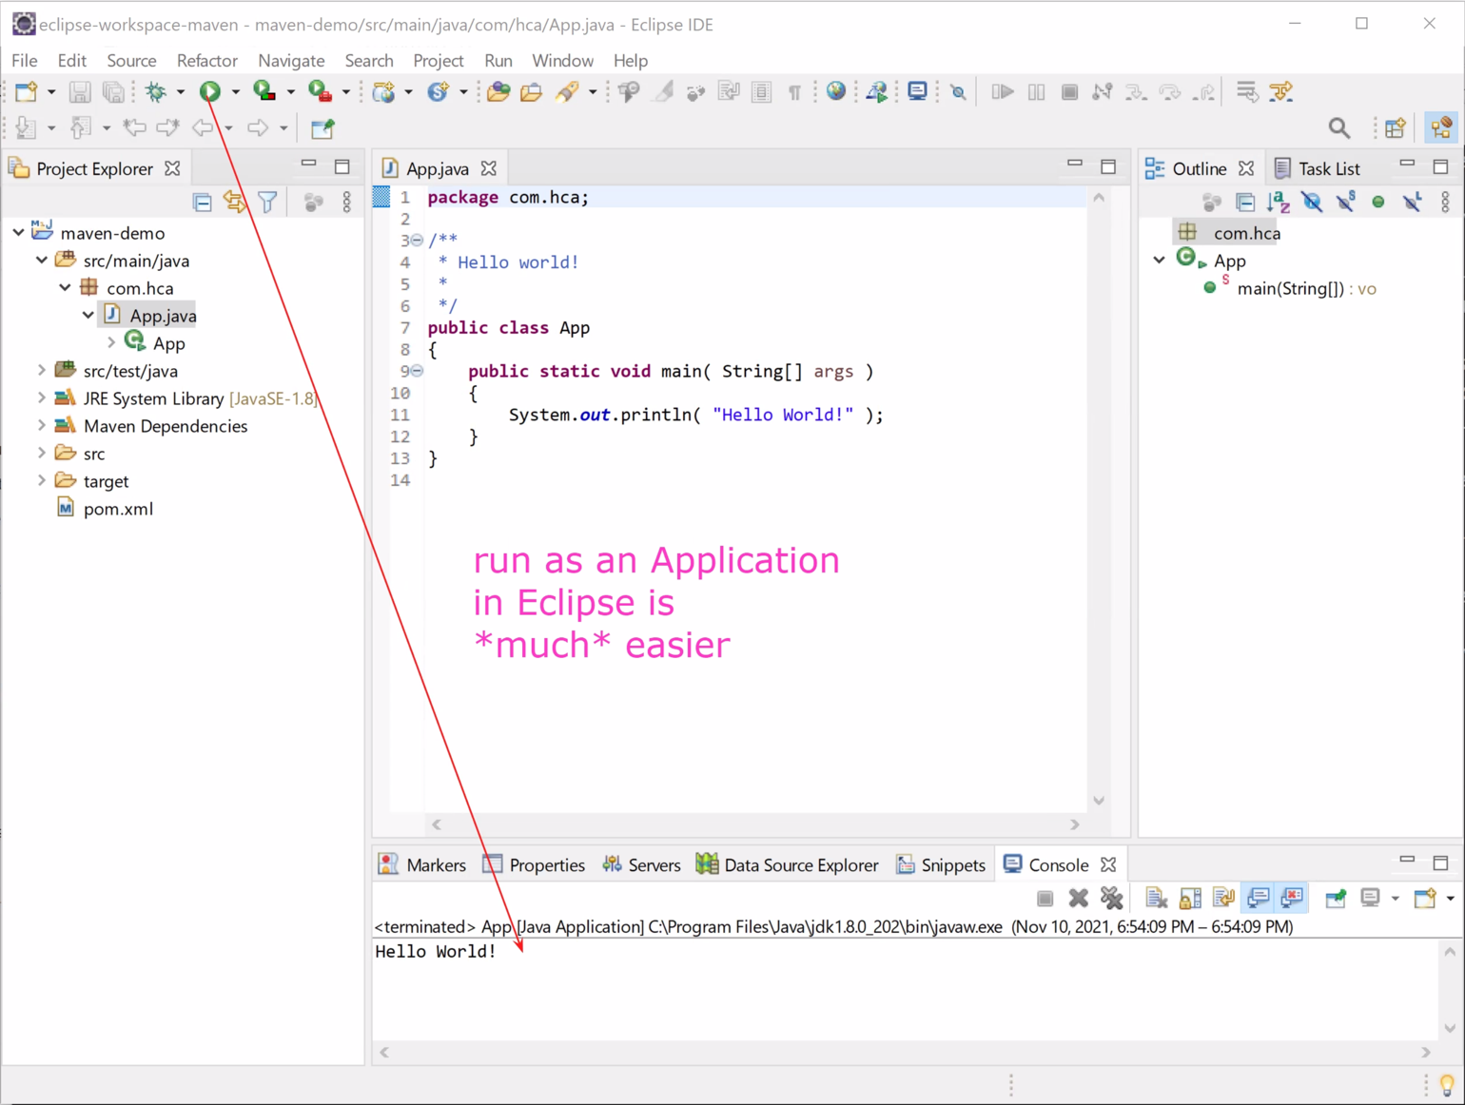

Adding A Run Configuration in Eclipse
for Maven

Click on the arrow next to the run button and open “Run Configurations…”

Then, right-click on “Maven Build” and select “New Configuration”

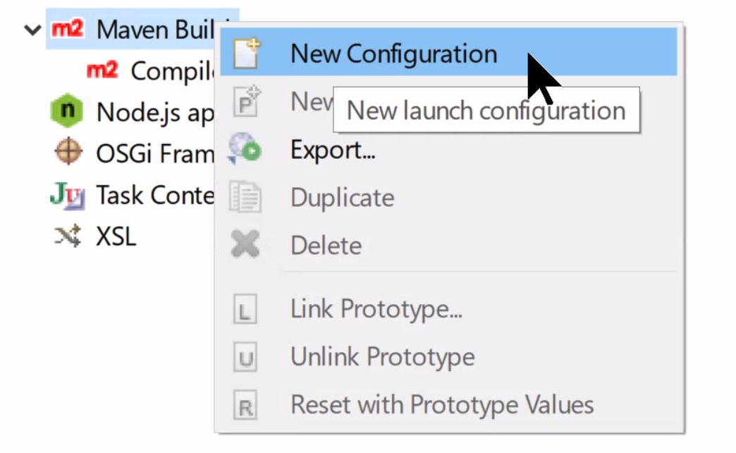

Creating a Run Configuration for Maven

Creating a Configuration called run, you can create a configuration with another name and in goals you can enter “compile exec:java”

exec:java is a plugin that runs java programs

You can add a property in the parameter name section of your run configuration

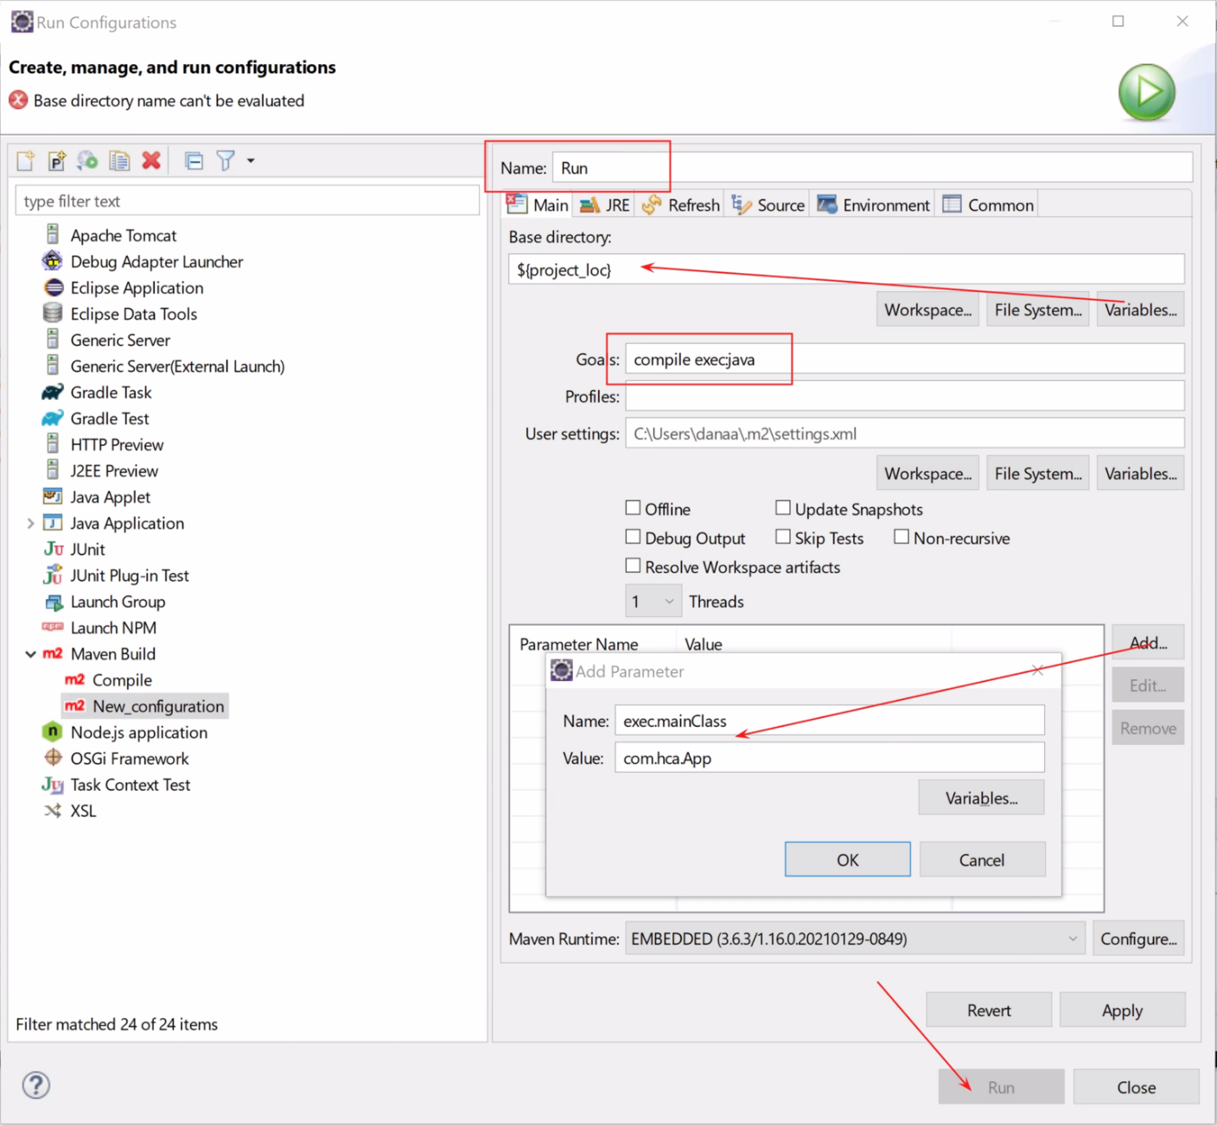

Creating a Run Configuration for Maven cont'd

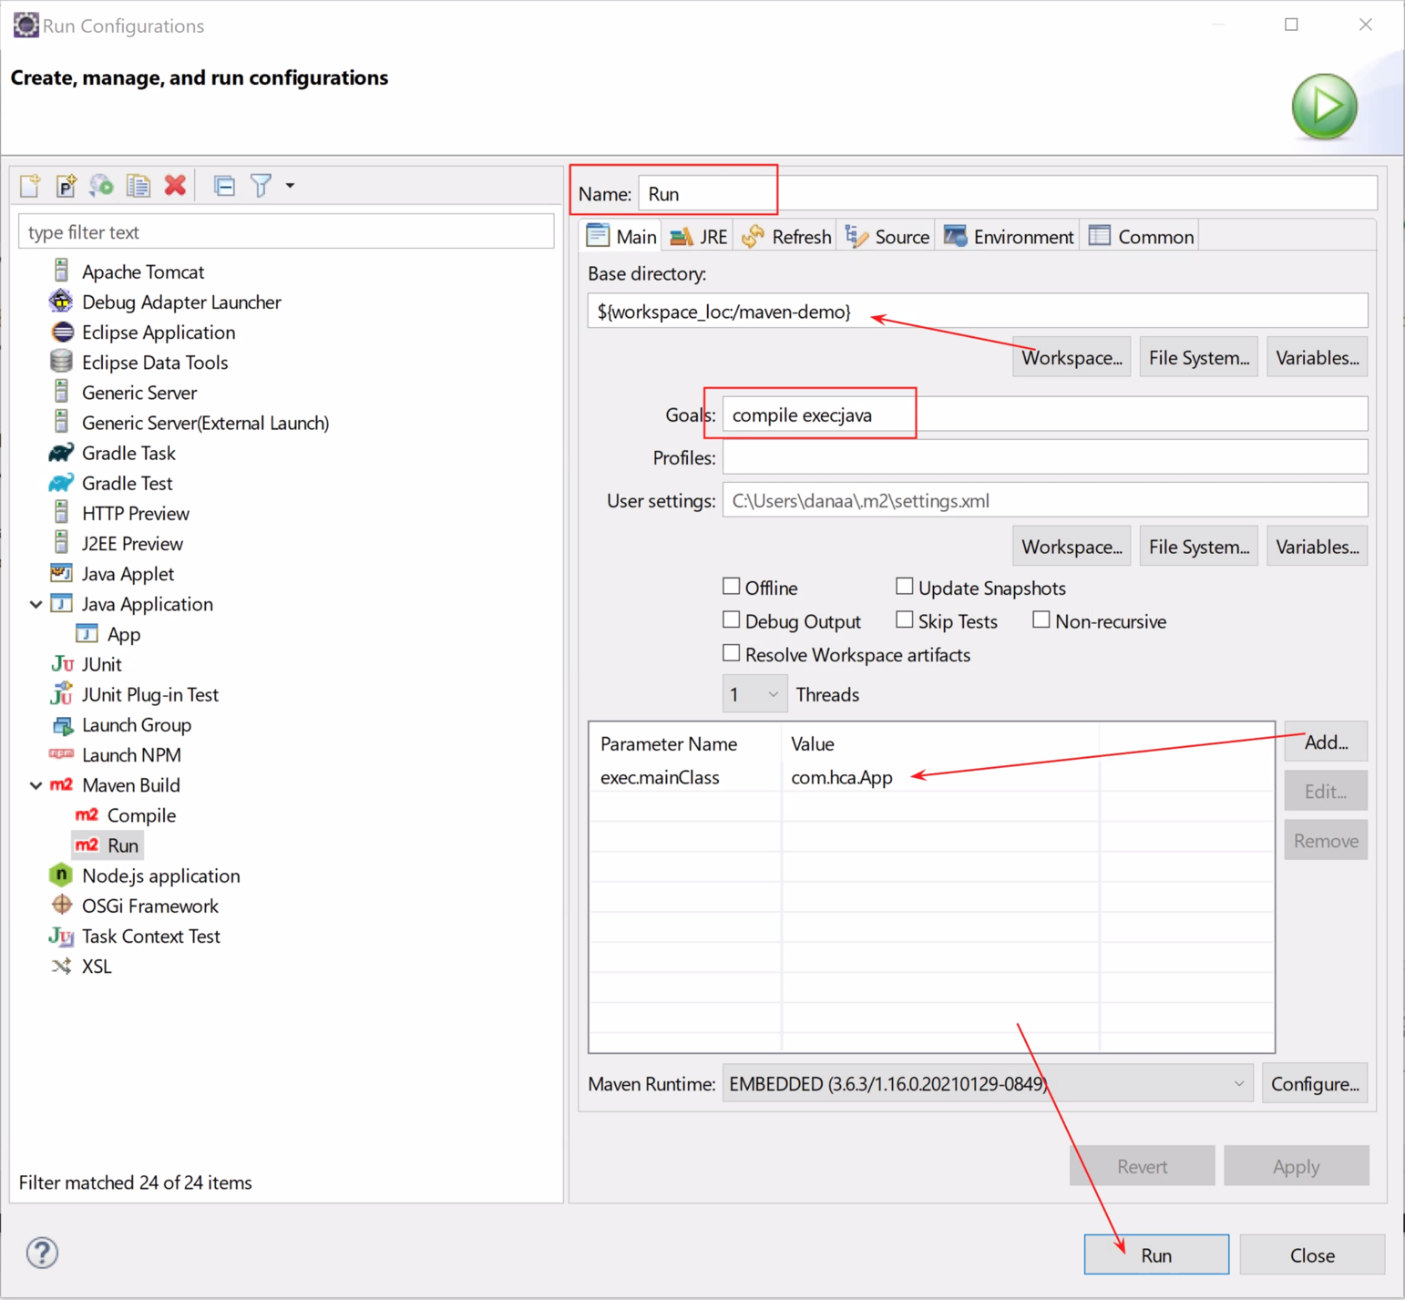

Viewing the Run
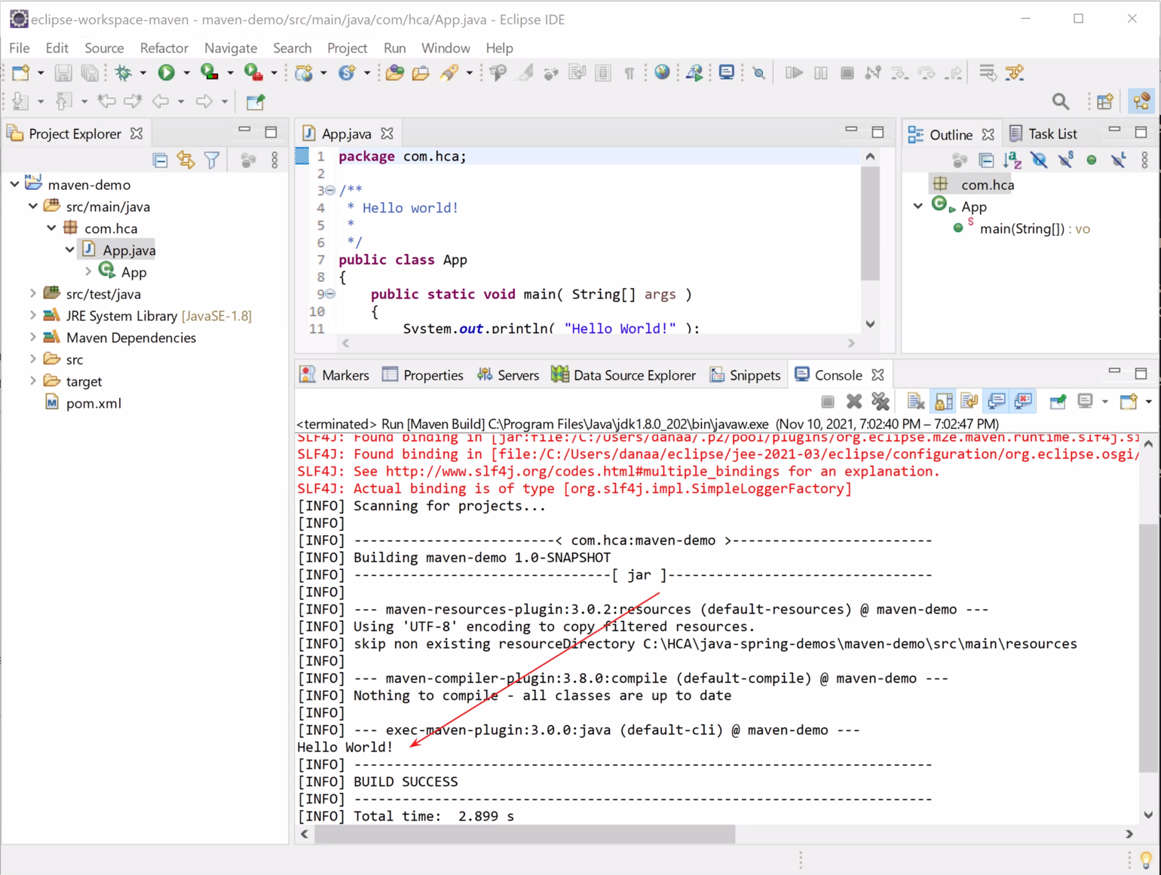

Exercises
EXERCISE 1
- Import the project you created in the previous exercise in IntelliJ.
- Set up the JRE.
- Add a run configuration for Maven.
- Run the project.

Adding to the Maven pom.xml

The pom.xml file in Eclipse

The Project Object Model (pom) file is an XML file that contains metadata and configuration details for building the project

One common thing to modify in the pom.xml is adding or changing dependencies for your project

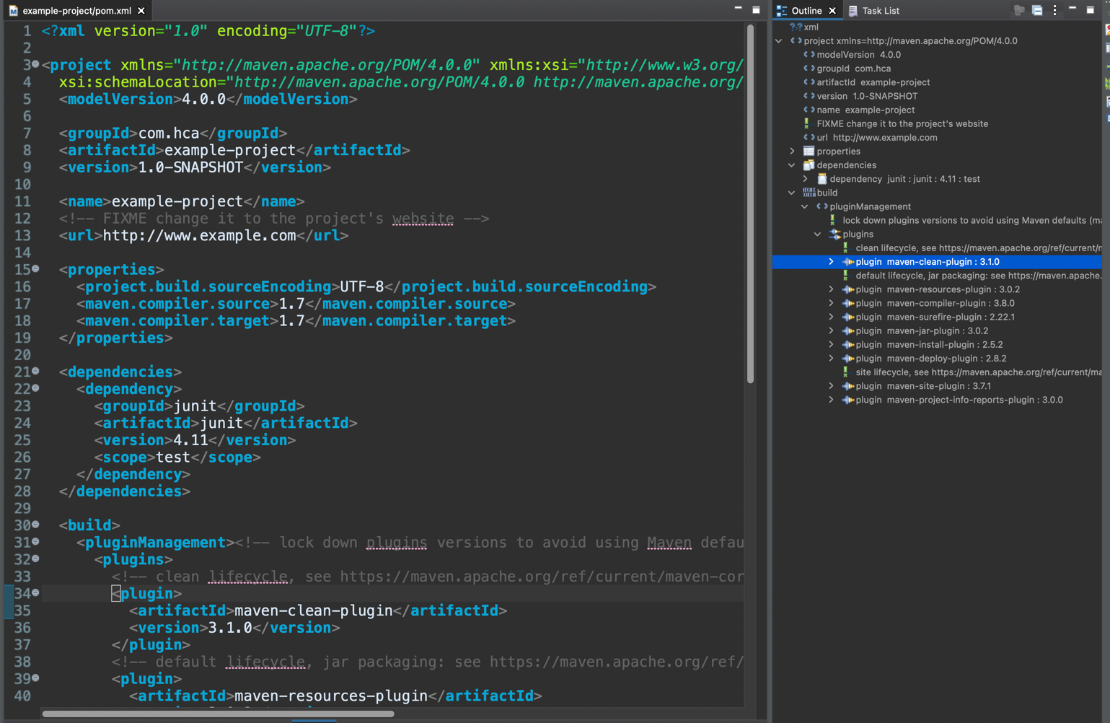

When to add dependencies

Whenever you want to use a third-party library in your project, you’ll need to make sure this is added to your dependency list.

For example, when we want to use the Jackson ObjectMapper, we need to add the Jackson dependency

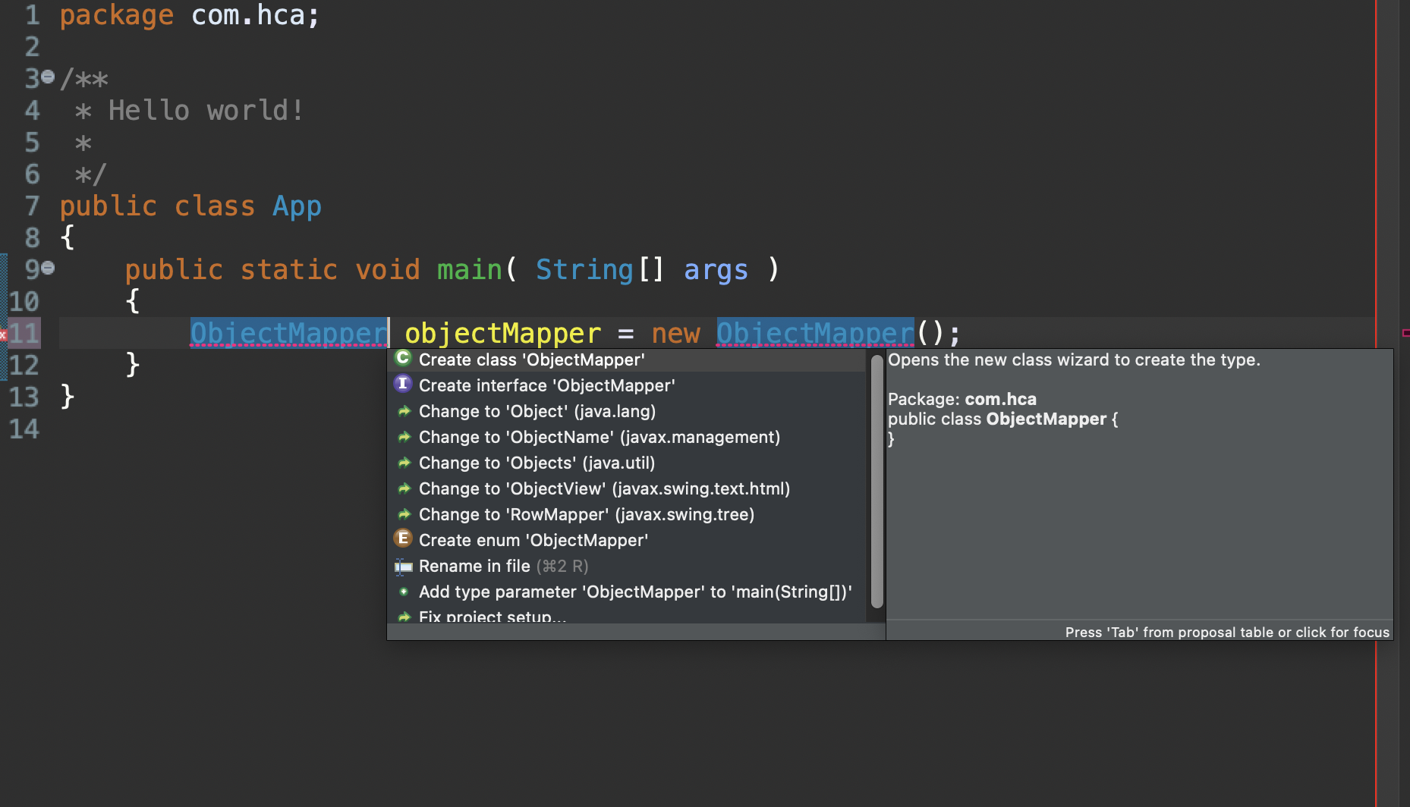

It cannot find the package from where to import the library, because it is not added to the project

How to add dependencies

We add a <dependency> node to our XML file in the <dependencies> node
Example
<dependency>
<groupId>hca.com</groupId>
<artifactId>example</artifactId>
<version>1.02</version>
</dependency>

After adding a dependency we’ll need to make sure that the project gets updated (typically happens in Eclipse after saving the pom.xml)

If it doesn’t, right-click on your Maven project and select Maven > Update Project

You should be able to open the Maven Dependencies and view all the jar files for your project

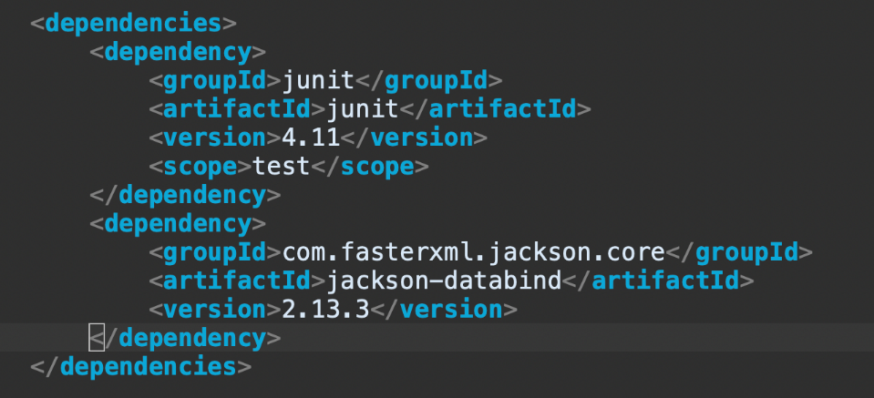

How to add dependencies cont'd

Now we’ve added the dependency, the suggested fixes can find the import with our ObjectMapper class in it

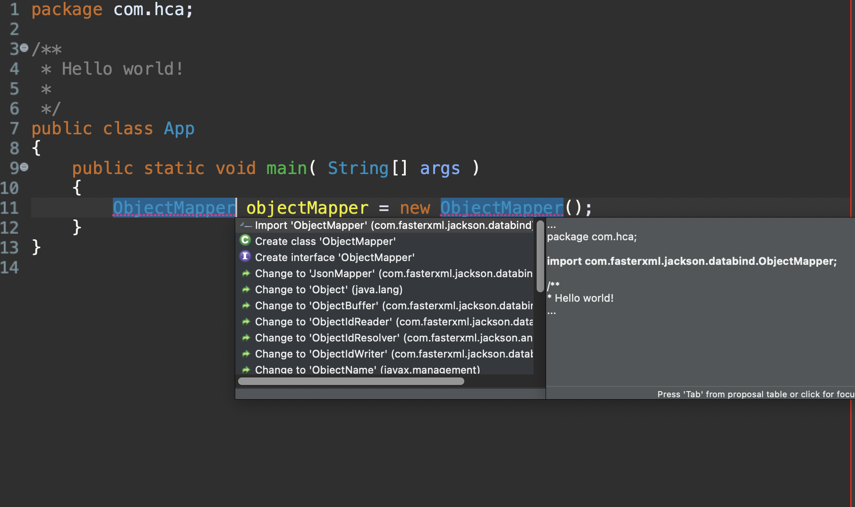

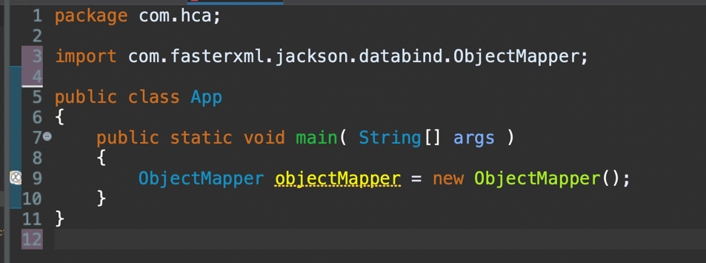

Exercises
EXERCISE 1
- Copy and paste the following code snippet in the App.java of your project (replace all other code except for the package statement)

public class App{

final static Logger logger = Logger.getLogger(App.class);

public static void main(String[] args) {

logMeLikeYouDo("☕");

}

private static void logMeLikeYouDo(String input){

if(logger.isDebugEnabled()){
logger.debug("This is debug : " + input);
}

if(logger.isInfoEnabled()){
logger.info("This is info : " + input);
}

logger.warn("This is warn : " + input);
logger.error("This is error : " + input);
logger.fatal("This is fatal : " + input);

}

}
- Add the necessary dependency (log4j) to get the imports on top of your file that are needed to get this code to run. This will require some googling.
- Make sure the project is updated and run the code. The code will run, but you don’t get the output you’d expect.
- BONUS: configure the project such that you can use log4j. Hint: the proper way to do this is adding a resources folder with a .properties file.

Spring Framework

Spring Framework

Spring Framework

In the early 2000s, a group of people led by Rod Johnson decided to build a framework that would make programming enterprise Java applications easier

It makes web programming easier, but it can also be used in Java applications as well

Spring is a framework that is used to bind objects together and manage scoping

The core of the Spring Framework is based on two principles:

dependency injection

inversion of control

Dependency Injection (DI) and
Inversion of Control (IoC)

The Dependency Injection design pattern is based on the idea that you pass to an object the things it needs (dependencies) rather than having it construct them itself

Example: Your data manager object might be passed in a DataSource identifying the database it needs to access instead of creating the DataSource object itself

Key takeaway: DI gives us loose coupling…

The Inversion of Control design pattern inverts the flow of control as compared to traditional control flow

Rather than the programmer explicitly creating an instance (e.g. new StudentService()) of a dependency and passing this instance to an object, the dependency is "received"

A framework is used to manage the process of creating instances of the dependencies and passing them in

Example: In Angular, you can register your services in app.module.ts and then declare them as parameters in component constructs and then ~voila~ they’re magically passed to component constructors by something deep in Angular!

Spring and DI / IoC

Inversion of Control externalizes the creation and management of component dependencies inside of a Java Application

Dependencies are injected by the Spring Inversion of Control (Ioc) Container at runtime

Inversion of Control == where the (Spring) framework takes control of your application

Dependency injection is how the Spring framework achieves Inversion of Control

This IoC container works with Dependency Injection to have the dependencies available at the locations necessary

This replaces a programmer manually passing an object into a constructor or a method

Example: if you create a Service that manages Student Registration, and you require an object that handles Database Access (a Database Access Object), you can inject the database access object into the service using Spring
Example
// example without DI
public class StudentRegistration {
private StudentDAO sDao = new StudentDAOImpl();

// rest of the class
}

// example with DI & Spring (and the correct configs in place)
public class StudentRegistration {
private StudentDAO sDao;

public StudentRegistration(StudentDAO sDao) { }

// rest of the class
}

Spring provides classes, configuration files, annotations, etc. to make this magic happen

Styles of Dependency Injection

Dependencies can be injected into an object in three ways:

through a constructor

through a setter method

through a field

Constructor dependency injection occurs when a component’s dependencies are provided to it in its constructor(s)

The IoC container passes (injects) the dependencies to the component when instantiation occurs and is managed by the Spring Framework

Example
public class StudentRegistration {
private StudentDAO sDao;
//constructor dependency injection:
@Autowired
public StudentRegistration(StudentDAO sDao) { … }

// here, an instance sDao will be provided by the Spring
// Framework, as opposed to creating an instance yourself
}

Setter dependency injection occurs when a component’s dependencies are provided to it via a setter method

The IoC container passes (injects) the dependencies via setter methods (e.g. setDataSource()).

Example
public class StudentRegistration {
private StudentDAO sDao;

public StudentRegistration() { }

// code omitted

@Autowired
public void setStudentDAO(StudentDao sDao) {
this.sDAO = sDAO;
}

// rest of the class
}

Field dependency injection occurs when a component’s dependencies are provided to it via the field

The IoC container passes (injects) the dependencies via the declaration of the field

Not the preferred DI option due to performance issues
Example
public class StudentRegistration {
@Autowired
private StudentDAO sDao;

// rest of the class
}

Example: Simple Spring App

Getting Started with a Basic Spring Application

Create an Application in Maven (you can use the archetype we created earlier)

Then, add Spring as a dependency in pom.xml because we want to use it in our application

Add a Spring version into Maven within the <properties> section of the pom.xml
Example
<org.springframework.version>5.2.8.RELEASE</org.springframework.version>

Now, add this dependency that references the property variable to your pom.xml:
Example
<dependency>
<groupId>org.springframework</groupId>
<artifactId>spring-context</artifactId>
<version>${org.springframework.version}</version>
</dependency>

The completed maven pom.xml would be (ensure that maven compiler source and target are set to 11):
Example
<project xmlns="http://maven.apache.org/POM/4.0.0"
xmlns:xsi="http://www.w3.org/2001/XMLSchema-instance"
xsi:schemaLocation="http://maven.apache.org/POM/4.0.0 http://maven.apache.org/xsd/maven-4.0.0.xsd">
<modelVersion>4.0.0</modelVersion>

Getting Started with a Basic Spring Application cont'd

<groupId>com.intuit</groupId>
<artifactId>basic-spring</artifactId>
<version>1.0-SNAPSHOT</version>

<name>basic-spring</name>
<!-- FIXME change it to the project's website -->
<url>http://www.example.com</url>

<properties>
<project.build.sourceEncoding>
UTF-8
</project.build.sourceEncoding>
<maven.compiler.source>11</maven.compiler.source>
<maven.compiler.target>11</maven.compiler.target>
<org.springframework.version>
5.2.8.RELEASE
</org.springframework.version>
</properties>

<dependencies>
<dependency>
<groupId>junit</groupId>
<artifactId>junit</artifactId>
<version>4.11</version>
<scope>test</scope>
</dependency>
<dependency>
<groupId>org.springframework</groupId>
<artifactId>spring-context</artifactId>
<version>${org.springframework.version}</version>
</dependency>
</dependencies>

NOTE: Plugins not shown

Ensuring Dependencies are Loaded into IntelliJ

This is very important! After you add a Dependency, like Spring, you must tell IntelliJ / Maven to update

You will see an icon that has the Maven “m” and blue arrows on it - like below - just click on that and Maven will download any of the new dependencies for you.

It will put those dependencies in the ~/.m2 directory and they will show up in the External Libraries folder which you should should see in the Project view on the left

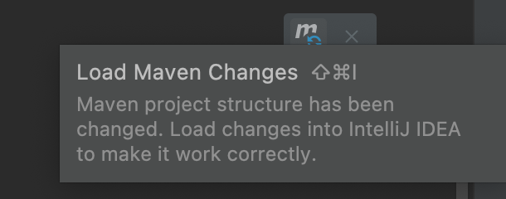

Java Beans

JavaBeans are Java classes that follow certain conventions

JavaBeans are used outside of the Spring Framework as well - they are not only used in Spring

JavaBeans are a specific type of POJO’s (Plain old Java Objects)

It’s a Java class that should adhere to the following 3 conventions:

Must implement Serializable Interface - this tells Java that objects of the class can be converted to a sequence of bytes which can then be persisted to a file, stored in a database, or sent over a network

It should have a public parameterless constructor

All properties in Java bean must be private with public getters and setter methods and stick to naming conventions for these
Example
package com.intuit.demo;

import java.io.Serializable;

public class Person implements Serializable {

// Private properties
private String name;

// Default Constructor - no parameters
public Person() {}

// Getters / Setters
public void setName(String name) {
this.name = name;
}
public String getName() {
return name;
}
}

Spring Beans

A Spring bean is an instance of a class, whose lifecycle is managed by the Spring container. These Spring beans can be injected elsewhere in the application.

It’s a Java class that is marked as a Spring bean:

This can be done in an XML file (that sticks to specific conventions) such as the example below
Example
<beans xmlns="http://www.springframework.org/schema/beans" xmlns:xsi="http://www.w3.org/2001/XMLSchema-instance"
xmlns:context="http://www.springframework.org/schema/context" xsi:schemaLocation="http://www.springframework.org/schema/beans/spring-beans-3.0.xsd">
<bean class="com.intuit.example.ExampleClassName">
<property name="field" value="example "></property>
</bean>
</beans>

Since version Spring 3 it is possible to define beans in a JavaConfig instead of an XML file. This is a Java class that is annotated with @Configuration.
Example
@Configuration
public class SomeConfig {
@Bean
public StudentService studentService() {
return new StudentService();
}
}

By marking a class with @Component (shown in just a bit).

Adding a beans.xml Configuration File

The beans.xml file is used to configure a Spring Application

In src/main/resources, add a beans.xml file

src/main/resources is used in Maven to store non-programming configuration files, images, data files, etc.

Copy the following:
Example
<?xml version="1.0" encoding="UTF-8"?>

<beans xmlns="http://www.springframework.org/schema/beans"
xmlns:xsi="http://www.w3.org/2001/XMLSchema-instance"
xmlns:context="http://www.springframework.org/schema/context"
xsi:schemaLocation="http://www.springframework.org/schema/beans
http://www.springframework.org/schema/beans/spring-beans-3.0.xsd
http://www.springframework.org/schema/context
http://www.springframework.org/schema/context/spring-context-3.0.xsd">

<context:component-scan base-package="com.intuit" />
</beans>

The component-scan tag tells Spring to scan that package and all the subpackages

It looks for all the classes with certain Spring annotations and remembers them

Adding a beans.xml Configuration File cont'd

IMPORTANT (note this only needs to be done in Eclipse, NOT IntelliJ): Add src/main/resources to your build path

Do this by right clicking on the folder src/main/resources > Build Path > Use as Source Folder

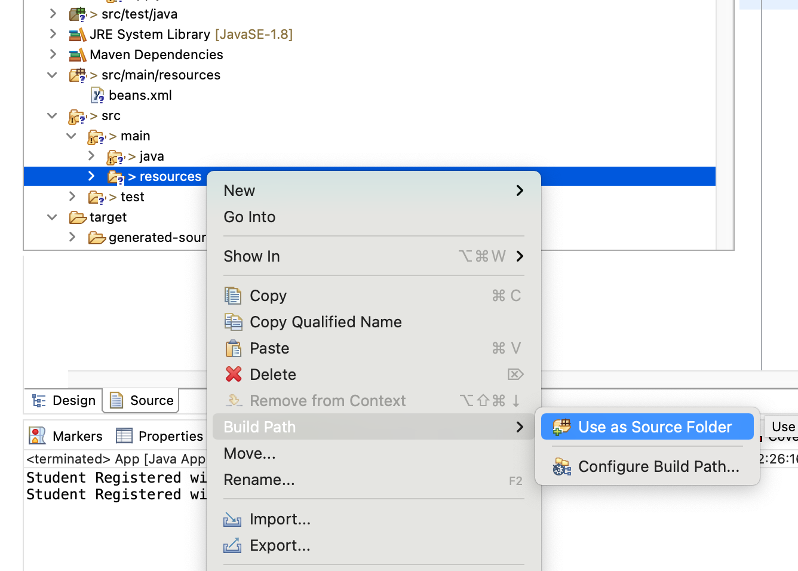

The result should look like the following:

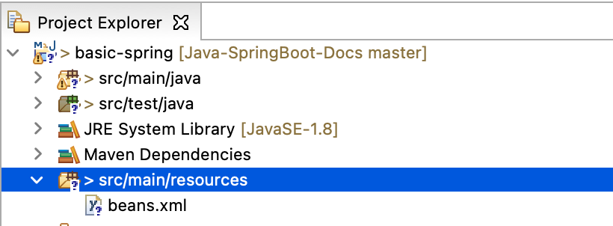

Example: Model for Student (go ahead and create a Student.java file with this code:)
Example
package com.intuit.model;

import java.util.Objects;

public class Student {
private Long id;
private final String firstName;
private final String lastName;
private final String major;

public Student(Long id, String firstName, String lastName,
String major) {
this.id = id;
this.firstName = firstName;
this.lastName = lastName;
this.major = major;
}

public Student(String firstName, String lastName,
String major) {
super();
this.firstName = firstName;
this.lastName = lastName;
this.major = major;
}

public Long getId() {
return id;
}

public String getFirstName() {
return firstName;
}

public String getLastName() {
return lastName;
}

public String getMajor() {
return major;
}

Example: Model for Student cont'd

@Override
public String toString() {
return "Student [id=" + id + ", firstName=" + firstName
+ ", lastName=" + lastName + ", major=" + major
+ "]";
}

@Override
public int hashCode() {
return Objects.hash(firstName, id, lastName);
}

@Override
public boolean equals(Object obj) {
if (this == obj) return true;
if (obj == null) return false;
if (getClass() != obj.getClass()) return false;

Student other = (Student) obj;
return Objects.equals(firstName, other.firstName)
&& Objects.equals(id, other.id)
&& Objects.equals(lastName, other.lastName);
}

}

Example: Creating a RegistrationDAO

This is an interface that represents a Data Access Object.

DAO pattern is a design pattern that separates the data access logic from the business logic (our Student in this case) in an application

It gives us a structured way to interact with a data storage system, such as a database and abstracts away the underlying implementation details of the database.

An implementation of the following interface would be responsible for handling, storing, and retrieving information in a database. Create this file as well:

package com.intuit.dao;

import com.intuit.model.Student;

public interface RegistrationDAO {
public Long persistStudent(Student student);
public Student findById(Long id);
}

Example: Implementing RegistrationDAO cont'd

This is an implementation of the RegistrationDAO object

Instead of running with an actual database we will make one out of an internal in-memory HashMap

This class will be marked with an @Component annotation to turn it into a bean

This is an annotation that tells Spring to inject an object of this class whenever a (Simple)RegistrationDAO is required.
Example
package com.intuit.dao;

import java.util.HashMap;

import org.springframework.stereotype.Component;

import com.intuit.model.Student;

// Component tells Spring to create an object from the class and
// identify it as RegistrationDAO type. This object is a Spring // bean If any other component
// requires a RegistrationDAO type it will use this object created
// by Spring.

// The default scope for the object is singleton. Which means that
// it will be available for the duration of the application
@Component
public class SimpleRegistrationDAO implements RegistrationDAO {

private HashMap<Long, Student> hashMap;
private Long counter = 60L;

public SimpleRegistrationDAO() {
this.hashMap = new HashMap<Long, Student>();

Example: Implementing RegistrationDAO

cont'd

this.hashMap.put(10L,
new Student(10L, "Marie", "Curie", "Science"));
this.hashMap.put(22L,
new Student(22L, "Albert", "Einstein", "Science"));
this.hashMap.put(44L,
new Student(44L, "Niels", "Bohr", "Science"));
this.hashMap.put(54L,
new Student(54L, "Carl", "Jung", "Psychology"));
}

@Override
public Long persistStudent(Student student) {
long freshId = counter++;
this.hashMap.put(freshId,
new Student(freshId, student.getFirstName(),
student.getLastName(),
student.getMajor()));
return freshId;
}

@Override
public Student findById(Long id) {
return hashMap.get(id);
}

}
Example: Creating a Registration Service

The RegistrationService is a class that registers a student

A Service usually is domain specific and not database specific in its method names

The Service requires a RegistrationDAO

The RegistrationDAO is an interface -- not a specific implementation

Notice the constructor -- it contains an @Autowired annotation which tells Spring, look for a @Component that is a RegistrationDAO and inject it here

The RegistrationService is also a bean because of the @Component and can be injected when required

Example
package com.intuit.service;

import org.springframework.beans.factory.annotation.Autowired;
import org.springframework.stereotype.Component;

import com.intuit.dao.RegistrationDAO;
import com.intuit.model.Student;

@Component
public class RegistrationService {

private final RegistrationDAO registrationDAO;

Example: Creating a Registration Service cont'd

// Autowired tells Spring to automatically inject a
// object into this constructor when a RegistrationService
// is created, more on this later

// When there’s only one constructor with args, @autowired
// is optional

@Autowired
public RegistrationService(RegistrationDAO registrationDAO) {
this.registrationDAO = registrationDAO;
}

public Long registerStudent(Student student) throws
StudentAlreadyRegisteredException {

if (this.registrationDAO.findById(student.getId())
!= null) {
throw new StudentAlreadyRegisteredException();
}

return registrationDAO.persistStudent(student);
}
}

Main Method

To start our application, we instantiate a ClasspathXMLApplicationContext and direct it to the /beans.xml file

Please ensure that src/main/resources is in the Eclipse build path, otherwise the application will not find the beans.xml

Once the context is established you can query for the object with all references assigned for you.
Example
package com.intuit;

import org.springframework.context.ApplicationContext;
import org.springframework.context.support.ClassPathXmlApplicationContext;

import com.intuit.model.Student;
import com.intuit.service.RegistrationService;
import com.intuit.service.StudentAlreadyRegisteredException;

public class App {
public static void main(String[] args) throws
StudentAlreadyRegisteredException {

// Open beans.xml where in this file there is a directive
// called component-scan Spring scans the files in the
// package declared looking for annotations like
// @Component and @Autowired. Spring will then do the
// wiring for you.

ApplicationContext ctx =
new ClassPathXmlApplicationContext("/beans.xml");

Main Method cont'd

// Pluck out the Registration Service from Spring. Think
// of your application like black box and you are asking
// for a component of a certain type.
// RegistrationService will already have the
// DataAccessObject injected into it by the time
// you receive this reference

RegistrationService registrationService =
ctx.getBean(RegistrationService.class);

Long studentID = registrationService.registerStudent(
new Student("Alan", "Turing", "Computer Science"));

System.out.println("Student Registered with ID: "
+ studentID);
Long studentID2 = registrationService.registerStudent(
new Student("Johannes", "Kepler", "Astronomy"));

System.out.println("Student Registered with ID: "
+ studentID2);
}
}

Example: Exception Used in the Service

Example
package com.intuit.service;

public class StudentAlreadyRegisteredException extends Exception {

}

Final Project Structure

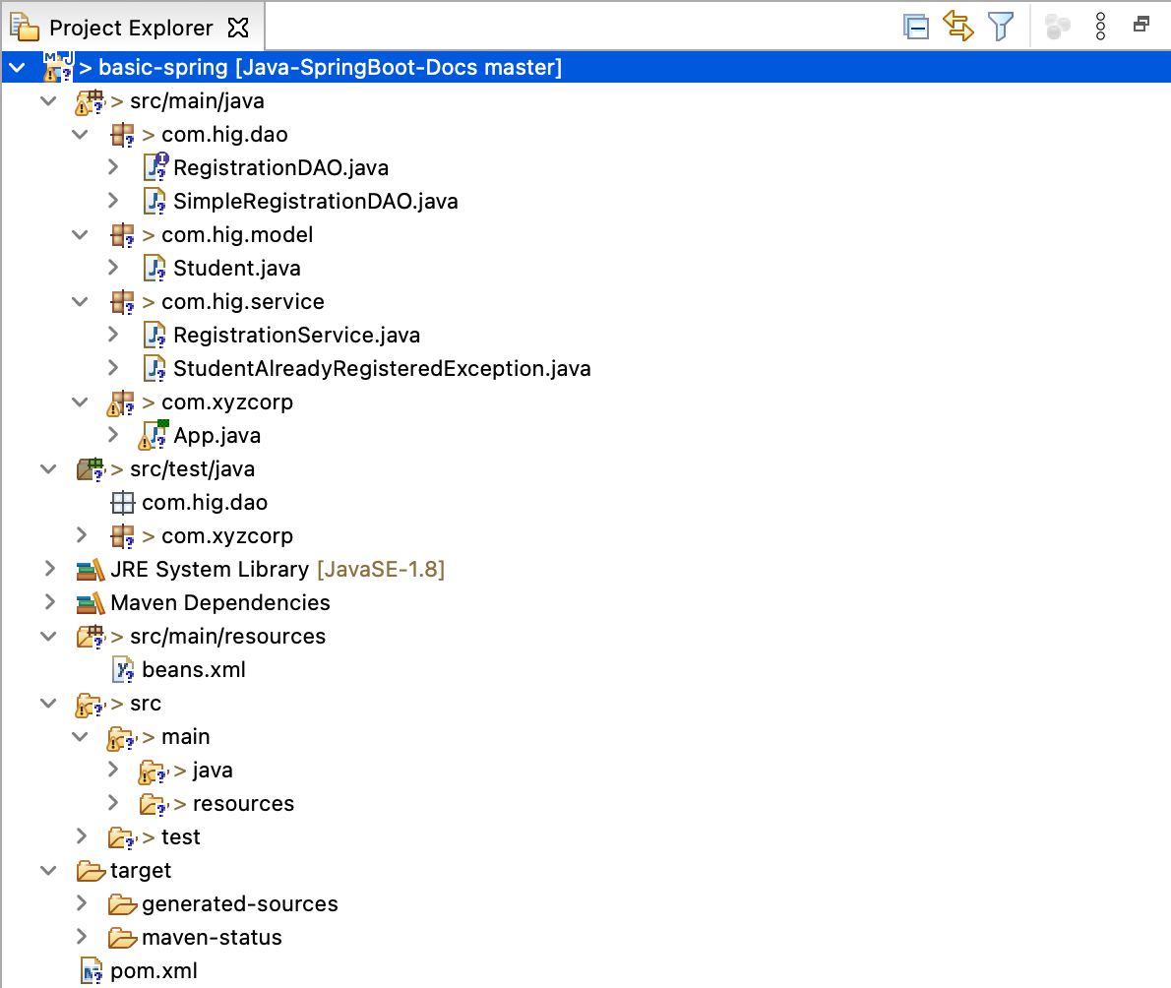

Exercises
We are going to recreate our HR app.
EXERCISE 1
- Create an application in Maven
- Add the Spring version to your pom.xml
- Add the Spring framework dependency to your pom.xml
- Add a beans.xml configuration file and let it point to the correct base package for finding beans
- Create a model for employees
- Create an EmployeeDAO interface for CRUD (Create Read Update Delete) operations on employees
- Create a basic implementation for your EmployeeDAO
- Create a service class for your Employee model in which there are methods for the CRUD operations on your employee objects that use the basic implementation of the EmployeeDAO interface.
- Add a custom exception for double registration of an employee and throw this from the service class when the employee already exists.
- Finally, add the main method for your Spring project and run the project.
- Now, add another implementation of the EmployeeDAO interface - use a LinkedHashMap instead of a Hashmap. With 2 implementations of the interface, how does Spring determine which one to use?

Spring Boot

Getting started with Spring Boot

Spring Boot

Preconfigured “Out-of-the-box” Spring Application.

Opinionated view of the Spring Framework with a set of libraries and extensions that are “Spring approved” and ready to go.

Provides production-ready features, like metrics and health checks which are required for microservices.

All annotation based, with little to no required XML configuration.

Building small, self-contained, ready to run applications can bring great flexibility and added resilience to your code.

Why Spring Boot? Because it helps you build production-ready applications faster

Getting Started with Spring Boot

Use start.spring.io to create a “web” project.

Select Maven as the project and Java as language, then for spring boot version select 3.3.1, and for everything else just leave the defaults alone - Java version should be set to 17

In the “Dependencies” dialog search for and add the “web” dependency as shown in the screenshot.

Hit the “Generate” button, download the zip, and unpack it into a folder on your computer.

The download, if you selected Maven as your build tool, will be ready to go and will just require an import into IntelliJ
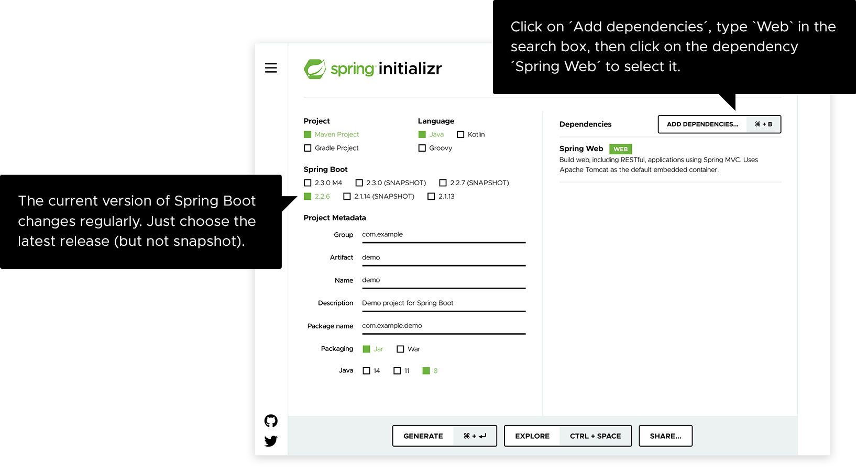

Creating an Intuit Demo

Visit https://start.spring.io/

Select Maven as Project, Java, a non snapshot version and in Dependencies add Spring Web

Click Download

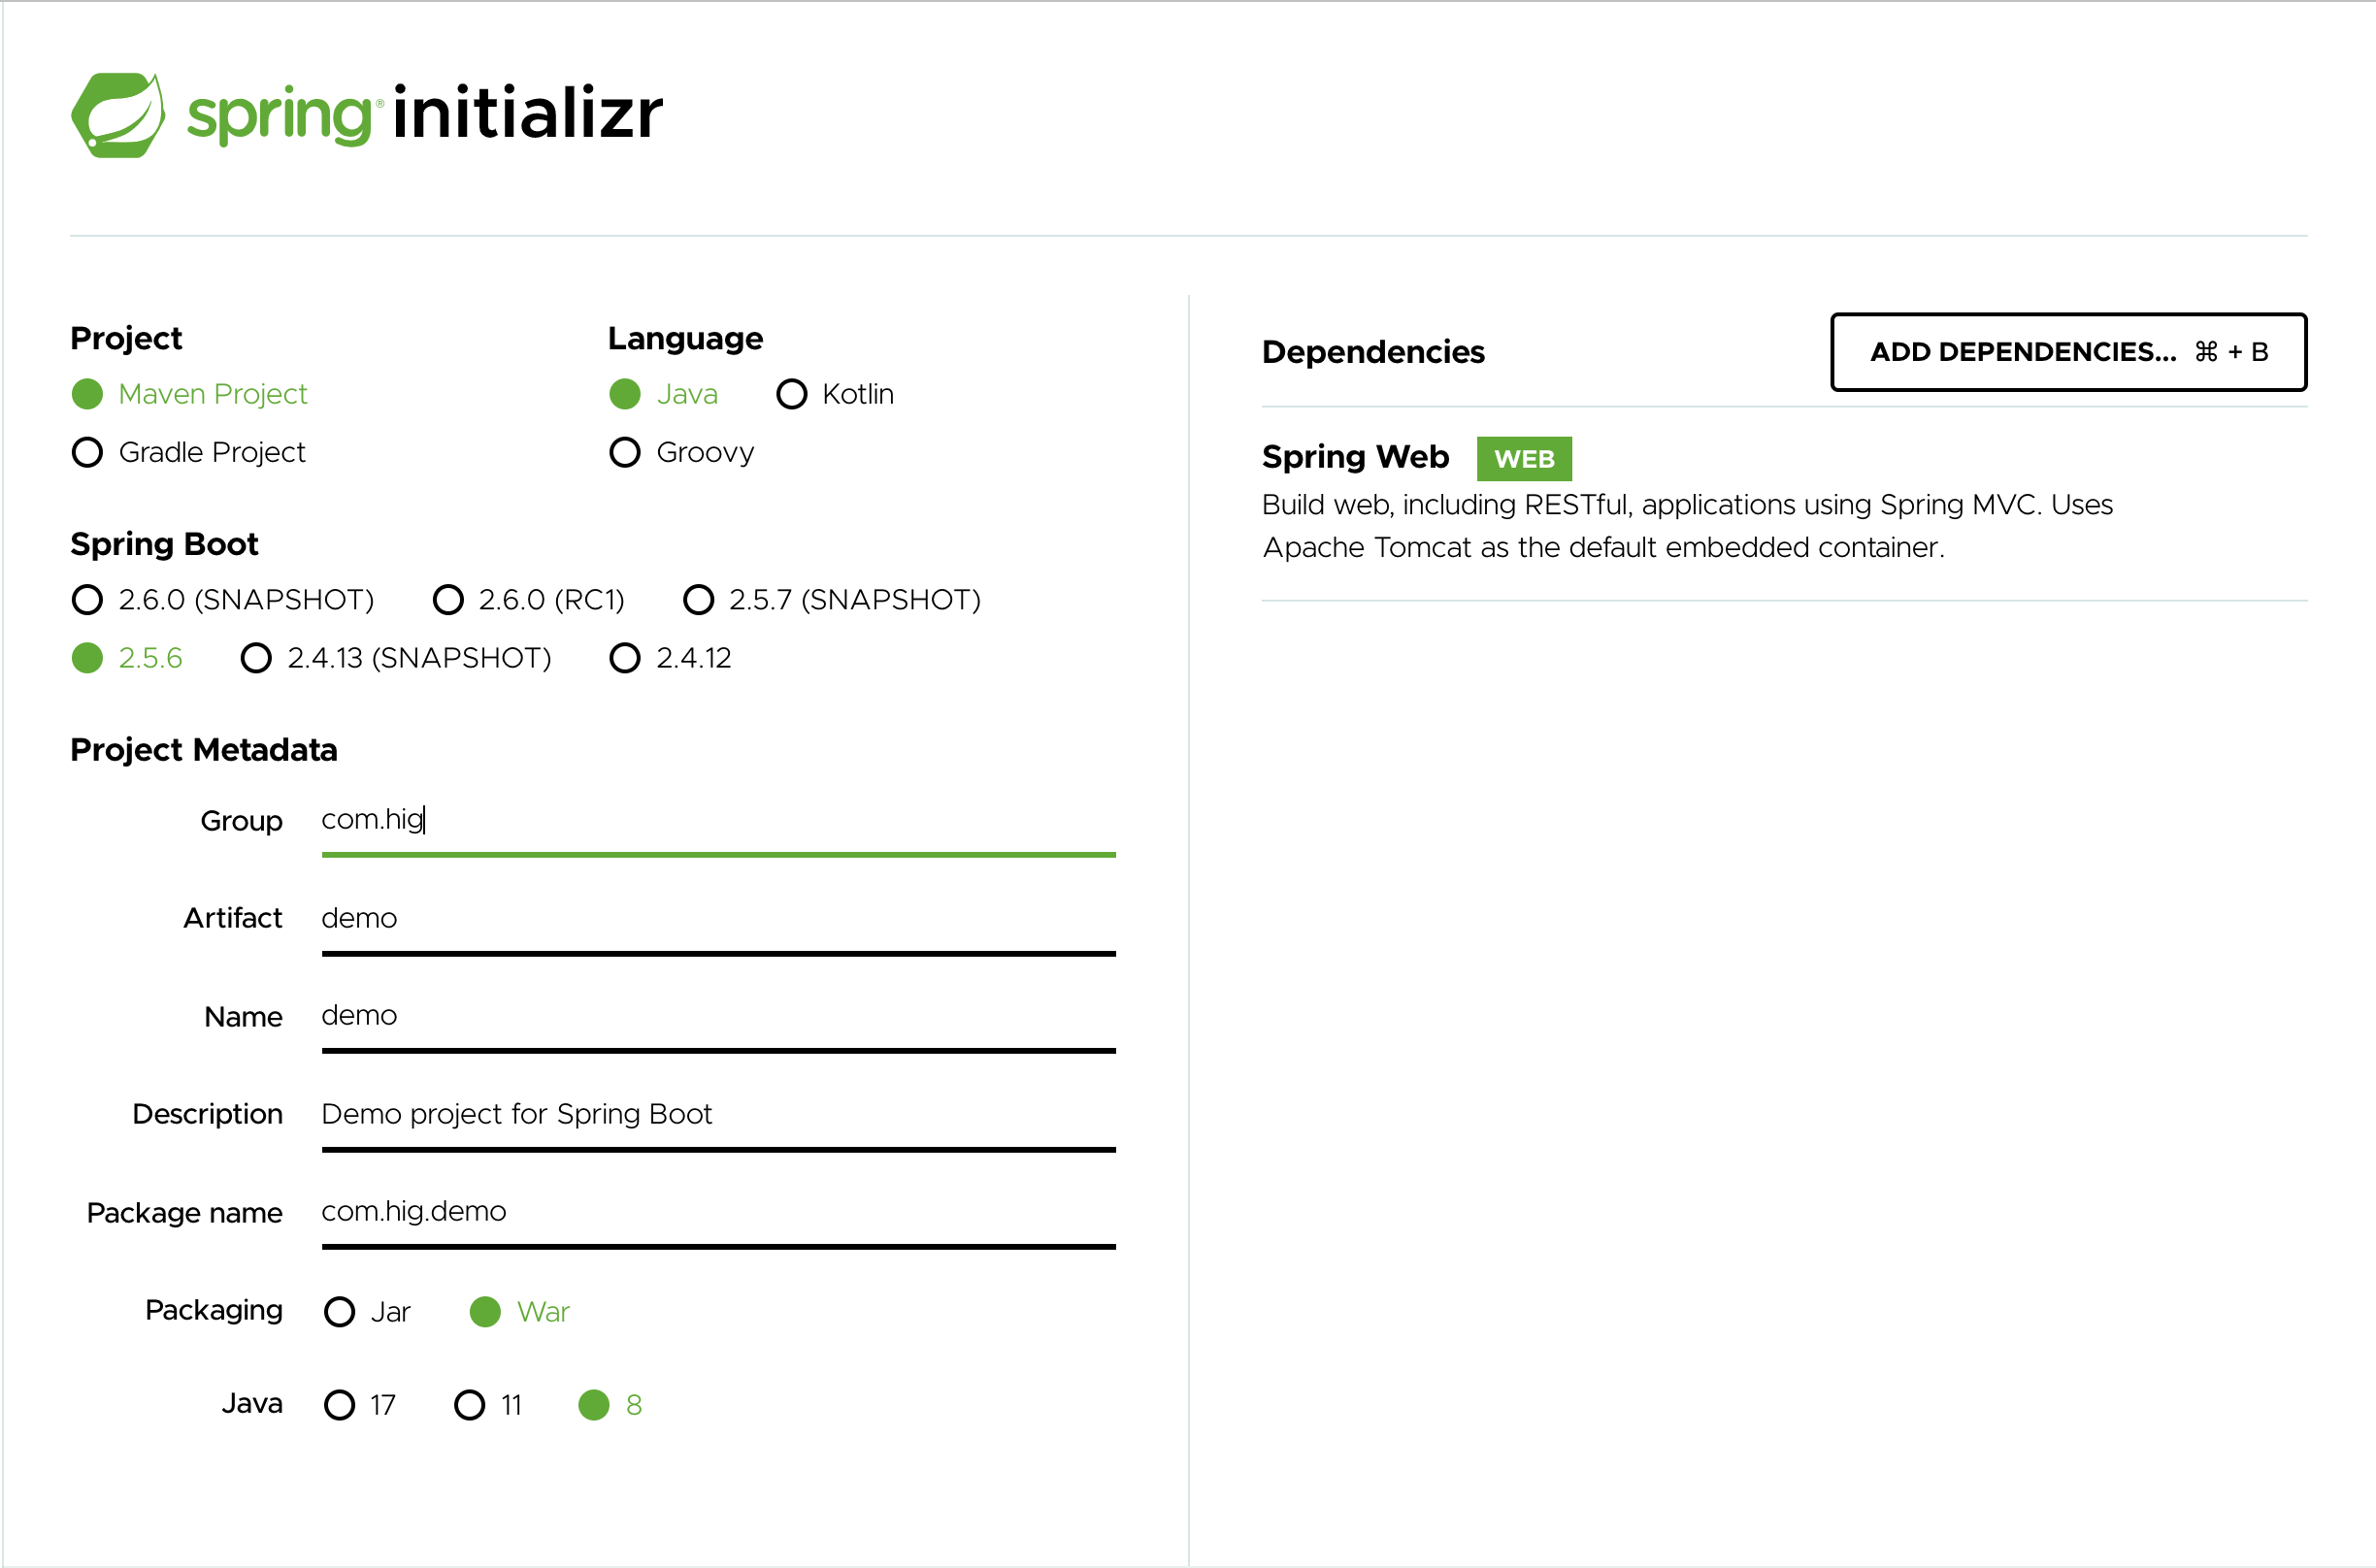

Bringing the Spring Boot App into IntelliJ

Once downloaded, unzip the file

In IntelliJ, File > Open-> click on the pom.xml, then click on Open as Project -> Trust Project

What do you get?

A fully configured project with

All initial settings made

All configurations made

All libraries are included

Even an included Maven binary so you don’t even need to download and install Maven.

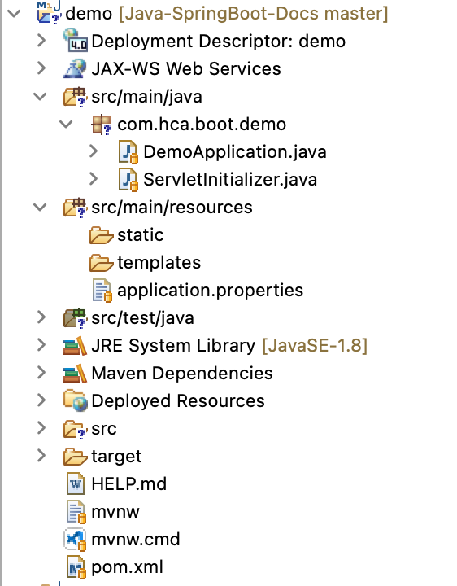

Exercises
Let’s create our first Spring Boot project!
- In your browser, go to https://start.spring.io/
- Select:
- Maven Project
- Java
- Latest stable Spring Boot version (so no snapshot)
- Give your project sensible metadata
- Jar
- Java version 17
- Don’t add any dependencies
- Generate the project
- Unzip the project and import it into IntelliJ
- Run the project

Annotations

Spring Boot relies heavily on the use of annotations for configuration (like the Spring Framework)

Annotations are a type of metadata that can be added to Java source code

Annotations have no direct effect on the operation of the code they annotate (although indirectly, yes, with IoC in Spring)

We have seen them already in Spring and also when we were working with inheritance and overriding methods in the child class: @Override

Annotations can be added to classes, methods, fields and more

Spring Boot: beans and dependency injection

Spring Beans and Spring Container

Beans in Spring Boot are the same as in the Spring framework, but they’re created differently. No more beans.xml file needed!

A Spring Bean is an instance of a class, managed by the IoC container.

The Spring IoC container is the core of the Spring Framework that configures the project and takes care of the dependency injection

We have seen a bean already in the sample project. The class that holds the main method is a bean!

Not all the classes are instantiated as beans, only the ones that are created using either the @Component or the @Bean annotation

There are a lot of beans present that are part of Spring, let’s inspect them by fetching the beans from the application context.

Inspecting the beans
@SpringBootApplication
public class ExampleApplication {

public static void main(String[] args) {
ApplicationContext ac = SpringApplication.run(ExampleApplication.class, args);
for(String bean : ac.getBeanDefinitionNames()) {
System.out.println(bean);
}
}

}

Output:

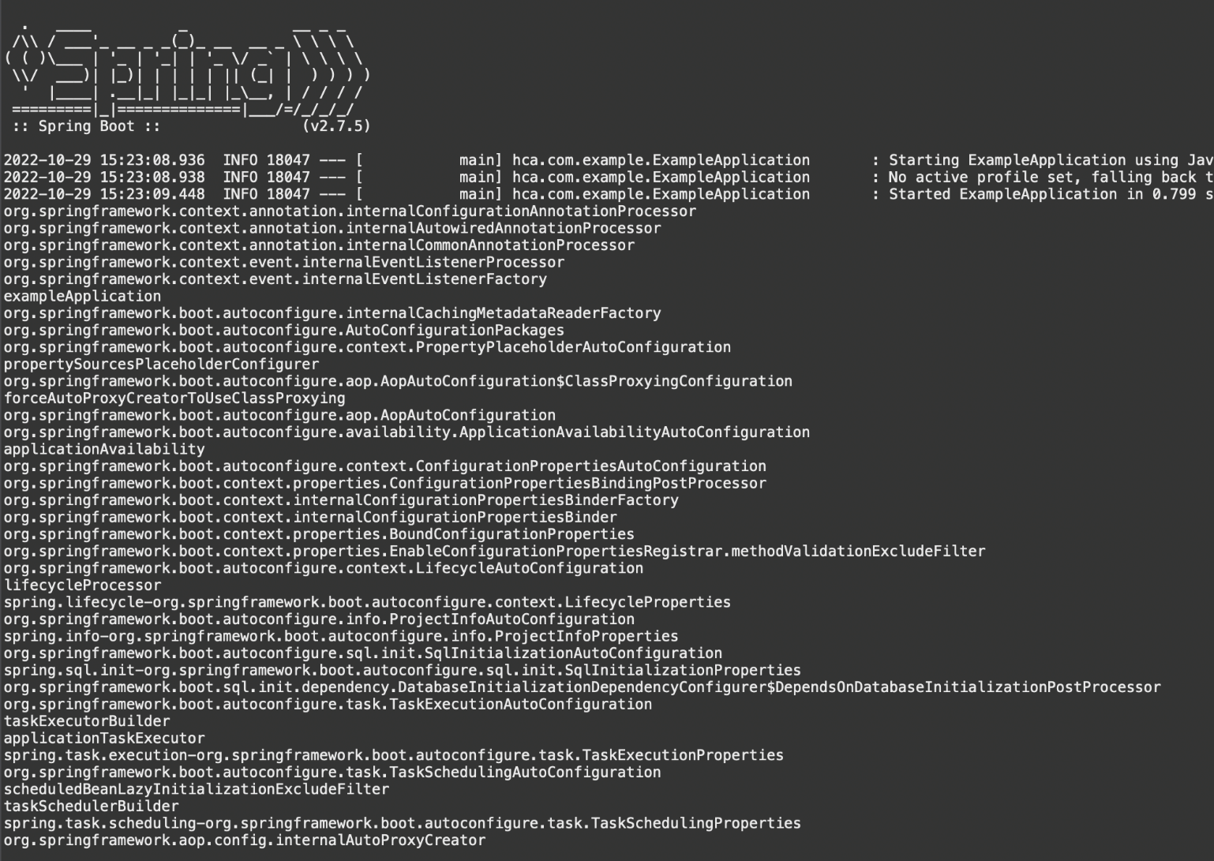

Creating Spring Bean with @Component

We can add beans to the application context, by adding @Component on top of a class
Example
package com.intuit.example;

import org.springframework.stereotype.Component;

@Component
public class ExampleBean {

}

If you run the code that outputs all the bean names again, you can see that it now contains a bean called exampleBean

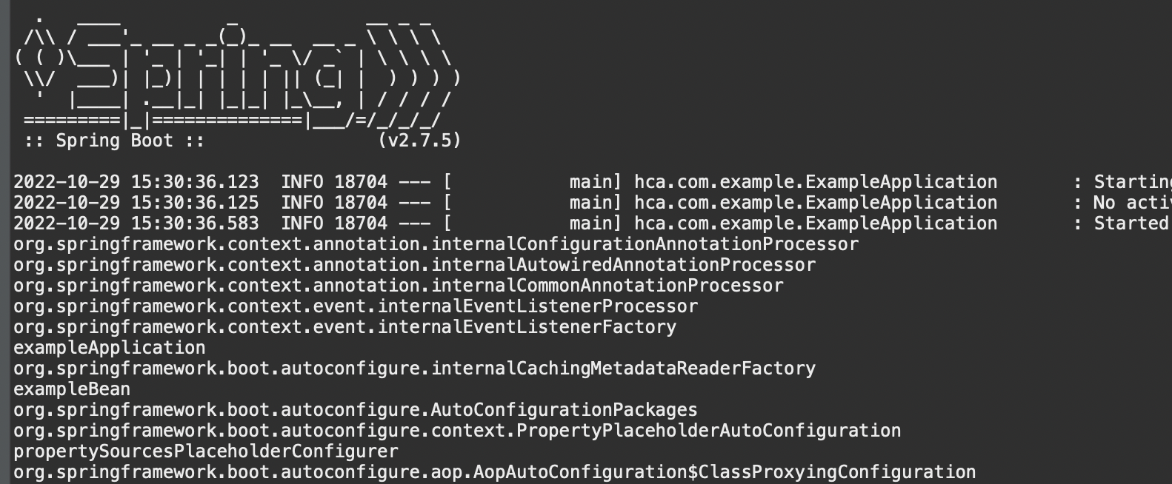

Creating Spring Bean with @Bean

In special files that are annotated with @Configuration (not @Component), we can create beans by using the @Bean annotation on top of a method
Example
import org.springframework.context.annotation.Bean;
import org.springframework.context.annotation.Configuration;

@Configuration
public class ExampleConfiguration {
@Bean
public String nameBean() {
return "Varoon";
}

}

The @Configuration annotation tells Spring to treat this class as a source of bean definitions

The @Bean annotation is used on methods within @Configuration classes to define a bean

What this method returns is going to be the bean in the application context

This way, you have more control over the exact content of the bean

The name of this bean will be the name of the method

The type of the bean will be String

Component scanning

Spring automatically scans for beans

It is important that the classes that need to become beans or contain methods annotated with @Bean are at the same level or a sublevel of the base package for component scanning, otherwise, the files are not found.

The default base package for component scanning is the class that has the @SpringBootApplication annotation

This project structure will find the beans: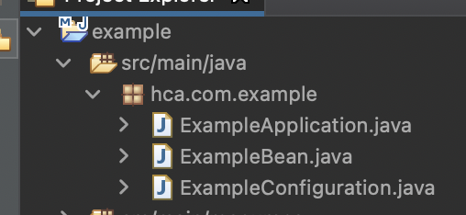

This project structure won’t find the beans, because the method containing the main method is at a lower directory level: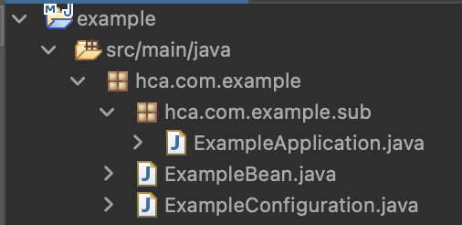

Exercises
We’re going to create bean soup.
- Create at least three different beans in your application using both ways to add beans (@Bean and @Component).
- Create a console application that asks for your favorite type of bean and checks whether this bean is present in the application context (this can be done in the class that contains the main method).
- If the type of bean is present, show a recipe for creating the specific bean soup.
- If it’s not present, show all the beans available in the application and let the user choose (if it’s a non-soup bean, print another recipe you’d recommend).
- BONUS: what happens if you have two configuration classes with both a bean of the same type with the same method name? Use Google to find a way to resolve this without changing the name of the method.

Dependency injection

Spring instantiates the beans

Sometimes beans have a property that is another bean

This property is being set to the instance of that type (bean) that exists in the application context

This phenomenon is called dependency injection
Example
Instead of doing something like this:

@Component
public class ExampleBean {
private String name = "Varoon";

}
Spring does the instantiation, and you can do this instead:

@Component
public class ExampleBean {
@Autowired
private String name;

}

Different dependency injection types

There are three types of dependency injection

Field injection

Constructor injection

Setter injection

Field injection is typically not recommended due to compromising the performance
Example

The example we’ve already seen uses field injection.

@Component
public class ExampleBean {
@Autowired
private String name;

}

Constructor injection is achieved by adding a constructor that takes the dependencies that are available as beans:

@Component
public class ExampleBean {
private String name;

@Autowired
public ExampleBean(String name) {
super();
this.name = name;
}

}

Different dependency injection types cont'd

Setter injection is achieved by adding @Autowired to the setter:

@Component
public class ExampleBean {
private String name;

public String getName() {
return name;
}

@Autowired
public void setName(String name) {
this.name = name;
}

}

Exercises
We’re going to create a class BeanSoup that’s a bean itself as well.
- Create a class for BeanSoup and make sure that it will be picked up as a bean.
- Give your class the following fields:
- A field that represents one of the beans in your application
- A field that represents a list of one of the other beans in your application
- A String name that is the name of the soup
- Generate getters and setters, and a constructor with fields and one without fields
- Run the application, inspect the possible error message.
- Add dependency injection for these three fields.
- Some of these fields need to be added as beans in your application. HINT: use the @Bean method for this.
- BONUS: Can you figure out how the container decides which beans to inject?

Which bean will be injected

The Spring IoC container needs to know which bean to inject

It primarily does this by using the type of the bean

When there is more than one bean of a certain type, it is going to look for:

@Qualifier annotation
Example
@Autowired
@Qualifier("nameBean")
public void setName(String name) {
this.name = name;
}

@Primary annotation on a bean to see which one is most important
Example
@Bean("anotherVaroonBean")
@Primary
public String nameBean() {
return "Varoon";
}

If nothing is found, it tries to autowire by name. If the field name matches the bean name, that one will be injected.

If none of these options resolve the question of which bean to inject, it is not going to manage to load the application context and the application will not start.

Exercises
We’re going to make our bean soup a little more complicated.
- We’re going to make sure that there are two beans of our field bean of the BeanSoup class in the application context.
- Run the program and inspect the outcome. Does it fail? If it doesn’t fail, rename the field in your BeanSoup class, it needs to fail!
- Solve the problem in three ways (undo the fix every time):
- By adding @Primary
- By using @Qualifier
- By renaming the field in your BeanSoup class

Spring Boot configuration

Configuring a Spring Boot application

There are different ways to configure a Spring Boot application

We can use the @Configuration class to add all sorts of configuration, amongst which @Bean methods that define beans

We are going to explore:

Using properties

Using profiles

Using properties

We can use properties from a property file

Property files are located in src/main/resources

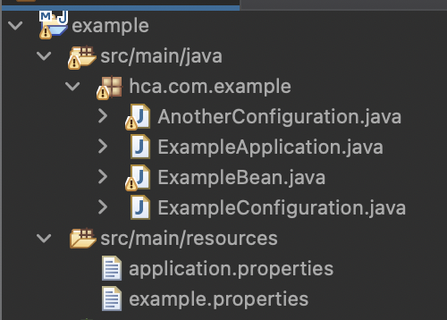
Example
greeting=hello

The properties can be used in classes by adding the source of the properties on top, using an annotation

The property can be used with the @Value annotation, @Value(${name.prop})

Using properties cont'd
Example
@Configuration
@PropertySource("classpath:example.properties")
public class ExampleConfiguration {
@Bean
public String nameBean() {
return "Varoon";
}

@Bean
public String valueProp(@Value("${greeting}") String hi) {
return hi;
}

}

In this example we configured a bean with the value from the property file, when we use this bean, the value from the property file will be used.

Example
@Component
public class ExampleBean {
private String valueProp;
private String nameBean;

@Autowired
public ExampleBean(String valueProp, String nameBean) {
this.valueProp = valueProp;
this.nameBean = nameBean;
System.out.println(valueProp + " " + nameBean);

}

}

Exercises
We are going to create a property file for configuring a database.
- Create a property file for the database configuration.
- Add properties with values for driverclassname, url, username and password in it.
- Create a class called TestDbConfiguration and give it the same fields as you have properties in the property file
- Make the class a bean by using the component annotation
- Use the property file to initialize the fields
Hint: if you print the result in the constructor, you can see whether it worked in the output when running the application

Using profiles

With properties we can configure our applications, but what if we wanted to have different configuration options available…

This is a common need, for example, different configurations for the development, test and production stage

This can be done with profiles

We can map a bean to a certain profile, this is done with the @Profile annotation
Example
In file DevConfig.java:
@Configuration
@Profile("dev")
public class DevConfig {
public String setting = "dev";

public DevConfig() {
System.out.println("In DevConfig constructor: " + setting);
}
}

In file TestConfig.java:
@Configuration
@Profile("test")
public class TestConfig {
public String setting = "test";

public TestConfig() {
System.out.println("In TestConfig constructor: " + setting);
}
}

Using profiles cont'd

There are many ways we can enable a certain profile, the one that we’re going to be using is by adding a property to the application.properties file

This property file is used for many configuration of a Spring Boot project
Example
spring.profiles.active=dev

When we run the application we see the text from the DevConfig constructor in our output and not the text from the TestConfig

Exercises
EXERCISE 1
You are going to create a new project for recipes.
- Create a class for Recipe and Ingredient.
- Give the class Recipe relevant fields amongst which a field “signatureIngredient” that is of type ingredient and that will be set using dependency injection.
- Give the Ingredient a field String name.
- Make Recipe a bean by adding the @Component annotation, make Ingredient a bean by adding a configuration file and specifying two beans for Ingredient in there.
- The first bean will be used for “regular” recipes and should get the profile regular. Give the name of the Ingredient a logical value for a regular recipe. (If you prefer a specific kitchen, go for it!)
- The second bean will be used for “vegan” recipes and should get the profile vegan. Give the name of the ingredient a logical value for a vegan recipe.
- In the constructor of recipe, print the select signatureIngredient.
- Choose the active profile. Run the applications twice, once for each profile.
- BONUS: can you find 3 different ways for setting the active profile? And can you print the active profile in the main?
EXERCISE 2 (optional challenge)
In this exercise, we’re going to combine the properties with @Value and profiles. We’ll continue from the previous project with the database configuration.
- Rewrite the class you already had to be the database for testing.
- Add another class for configuring the database for development.
- When the profile test is activated, the first configuration file should be used, when the profile dev is activated, the development configuration file should be used. Hint: configuration files are beans too!

